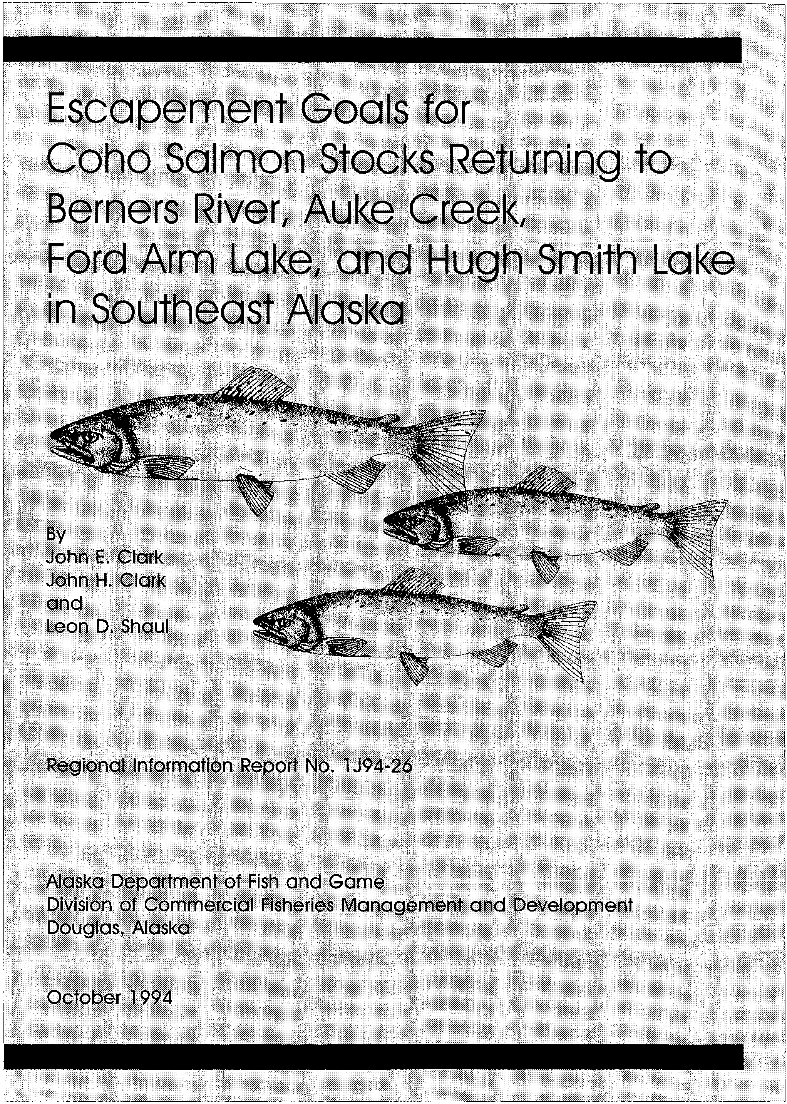

**ESCAPEMENT GOALS FOR COHO SALMON STOCKS RETURNING TO BERNERS RIVER, AUKE CREEK, FORD ARM LAKE, AND HUGH SMITH LAKE IN SOUTHEAST ALASKA**

**By**

**John E. Clark John H. Clark and**

**Leon D. Shaul**

**Regional Information Report No. 1 1 J94-26**

**Alaska Department of Fish and Game**

**Division of Commercial Fisheries Management and Development**

**Douglas, Alaska**

**October, 1 994**

1 The Regional Information Report Series was established in 1987 to provide an information access system for all unpublished divisional reports. These reports frequently serve diverse and ad hoc informational purposes or archive basic uninterpreted data. To accommodate timely reporting of recently collected information, reports in this series undergo only limited internal review and may contain preliminary data; this information may not be subsequently finalized and published in the formal literature. Consequently, these reports should not be cited without prior approval of the author or the Division of Commercial Fisheries Management and Development.

AUTHORS

John E. Clark is a biometrician employed by the Alaska Department of Fish and Game, Division of Commercial Fisheries Management and Development, Douglas Island Center Building, 802 3rd Street, Post Office Box 240020, Douglas, Alaska 99824-0020.

John H. Clark is a fishery biologist employed by the Alaska Department of Fish and Game, Division of Commercial Fisheries Management and Development, Capitol Office Park, 1255 West 8th Street, Post Office Box 25526, Juneau, Alaska

99802-5526.

Leon D. Shaul is a fishery biologist employed by the Alaska Department of Fish and Game, Division of Commercial Fisheries Management and Development, Douglas Island Center Building, 802 3rd Street, Post Office Box 240020, Douglas, Alaska 99824-0020 and responsible for coho salmon research in Southeast Alaska.

ACKNOWLEDGEMENTS

The National Marine Fisheries Service, Auke Bay Laboratory operated the Auke Creek weir and collected data on the Auke Creek coho stock with assistance from Alaska Department of Fish and Game staff. The authors appreciate the work of Jerry Taylor of the National Marine Fisheries Service in collecting data and maintaining a long-term database on the Auke Creek coho salmon stock. The authors also thank Jim Blick and Ben Van Alen for their review of this manuscript.

TABLE OF CONTENTS

LIST OF TABLES iii

LIST OF FIGURES. . . . . . . . . . . . . . . . . . . . . . . . . . . . . . . . . . . . . . . . . . . . . . . . . . . . . . . . . . . v

LIST OF APPENDIX TABLES. . . . . . . . . . . . . . . . . . . . . . . . . . . . . . . . . . . . . . . . . . . . . . . . . . . vii

|  |  |
| --- | --- |
| ABSTRACT.................................................................. | 1 |
| INTRODUCTION. . . . . . . . . . . . . . . . . . . . . . . . . . . . . . . . . . . . . . . . . . . . . . . . . . . . . . . . . . . . . . | 2 |
| METHODS .-................... | 3 |
| Data Collection Methods................................................ | 3 |
| Analytical Methods........ . . . . . . . . . . . . . . . . . . . . . . . . . . . . . . . . . . . . . . . . . . . . . | 4 |
| RESULTS.................................................................... | 7 |
| DISCUSSION : . . . . . . . . . | 11 |
| RECOMMENDATIONS. . . . . . . . . . . . . . . . . . . . . . . . . . . . . . . . . . . . . . . . . . . . . . . . . . . . . . . . . . . | 14 |
| LITERATURE CITED. . . . . . . . . . . . . . . . . . . . . . . . . . . . . . . . . . . . . . . . . . . . . . . . . . . . . . . . . . | 15 |
| APPENDIX TABLES : . . . . . . . . . . . . . . . . . . . . . . . . . . . . . . . . . . . . . . . . . . . | 64 |

ii

LIST OF TABLES



1. Berners River returns of coho salmon by year of return.............. 19

2. Auke Creek returns of coho salmon by year of return................. 20

3. Ford Arm Lake returns of coho salmon by year of return.............. 21

4. Hugh Smith Lake returns of coho salmon by year of return............ 22

5. Returns of coho salmon to the Berners River by brood year........... 23

|  |  |  |
| --- | --- | --- |
| 6. | Returns of coho salmon to Auke Creek by brood year.................. | 24 |
| 7. | Returns of coho salmon to Ford Arm Lake by brood year............... | 25 |
| 8. | Returns of coho salmon to Hugh Smith Lake by brood year............. | 26 |
| 9. | Total returns of coho salmon to the Berners River by brood·year adjusted to average marine survival conditions (estimated total returns adjusted to average marine survival conditions)............. | 27 |
| 10. | Total returns of coho salmon to the Berners River by brood year adjusted to low marine survival conditions (estimated total  returns adjusted to low (8.8%) marine survival conditions).......... | 28 |
| 11. | Total returns of coho salmon to the Berners River by brood year adjusted to high marine survival conditions (estimated total  returns adjusted to high (21.1%) marine survival conditions)........ | 29 |
| 12. | Total returns of coho salmon to Auke Creek by brood year |  |
|  | adjusted to average marine survival conditions (estimated total returns adjusted to average marine survival conditions)............. | 30 |
| 13. | Total returns of coho salmon to Auke Creek by brood year adjusted to low marine survival conditions (estimated total  returns adjusted to low (11.0%) marine survival conditions)......... | 31 |
| 14. | Total returns of coho salmon to Auke Creek by brood year adjusted to high marine survival conditions (estimated total  returns adjusted to high (17.1%) marine survival conditions)........ | 32 |
| 15. | Total returns of coho salmon to Ford Arm Lake by brood year |  |
|  | adjusted to average marine survival conditions (estimated total returns adjusted to average marine survival conditions)............. | 33 |
| 16. | Total returns of coho salmon to Ford Arm Lake by brood year adjusted to low marine survival conditions (estimated total |  |
|  | returns adjusted to low (6.5%) marine survival conditions).......... | 34 |

lll

LIST OF TABLES (continued)



|  |  |  |
| --- | --- | --- |
| 17. | Total returns of coho salmon to Ford Arm Lake by brood year adjusted to high marine survival conditions (estimated total |  |
|  | returns adjusted to high (15.7) marine survival conditions)........ | 35 |
| 18. | Total returns of coho salmon to Hugh Smith Lake by brood year |  |
|  | adjusted to average marine survival conditions (estimated total |  |
|  | returns adjusted to average marine survival conditions)............. | 36 |
| 19. | Total returns of coho salmon to Hugh Smith Lake by brood year |  |
|  | adjusted to low marine survival conditions (estimated total |  |
|  | returns adjusted to low (7.5%) marine survival conditions).......... | 37 |
| 20. | Total returns of coho salmon to Hugh Smith Lake by brood year |  |
|  | adjusted to high marine survival conditions (estimated total |  |
|  | returns adjusted to high (18.7%) marine survival conditions)........ | 38 |
| 21. | Estimated spawner-recruit parameters for four coho salmon stocks |  |
|  | using unadjusted and adjusted recruitment data sets................. | 39 |
| 22. | Estimated spawner-recruit parameters based on regressions and |  |
|  | bootstrap statistics for four coho salmon stocks with |  |
|  | unadjusted and adjusted recruitment estimates....................... | 40 |
| 23. | Optimum escapement estimates and lower and upper escapements |  |
|  | that are estimated to produce 90% of the maximum yield·based |  |
|  | on regressions of the spawner-recruit relationships along with |  |
|  | estimates of median optimum escapements with 90% confidence |  |
|  | bounds when recruitment errors were bootstrapped for four |  |
|  | coho salmon stocks. . . . . . . . . . . . . . . . . . . . . . . . . . . . . . . . . . . . . . . . . . . . . . . . . . | 41 |
| 24. | Recommended escapement goal ranges for four coho salmon stocks |  |
|  | with the number and percentage of times that monitored escapement |  |
|  | was within the range since escapements have been monitored.......... | 42 |
| 25. | Estimates of harvest rates for four coho salmon stocks at |  |
|  | maximum sustained yield and at 90% bounds of maximum sustained |  |
|  | yield............................................................... | 43 |
| 26. | Comparison of smolt freshwater age composition with returning |  |
|  | adult freshwater age composition for the Hugh Smith Lake stock |  |
|  | of coho salmon. . . . . . . . . . . . . . . . . . . . . . . . . . . . . . . . . . . . . . . . . . . . . . . . . . . . . . | 44 |
| 27. | Listing of long-term indicator stocks of coho salmon |  |
|  | compared with geographic stock groupings and types of coho |  |
|  | salmon producing systems found in Southeast Alaska and the U.S - |  |
|  | Canada transboundary rivers......................................... | 45 |

lV

LIST OF FIGURES

Figure

|  |  |  |
| --- | --- | --- |
| 1. | Map of Southeastern Alaska showing the locations of the Berners  River, Auke Creek, Ford Arm Lake, and Hugh Smith Lake............... | 46 |
| 2. | Spawner-recruit relationship for Berners River coho salmon using unadjusted total returns............................................ | 47 |
| 3. | Deviations from average marine survival and residuals in the  spawner-recruit relationship for Berners River coho salmon.......... | 48 |
| 4. | Spawner-recruit relationship for Berners River coho salmon using total returns adjusted to average marine survival conditions........ | 49 |
| 5. | Spawner-recruit relationship for Berners River coho salmon using total returns adjusted to low and high marine survival conditions............. . . . . . . . . . . . . . . . . . . . . . . . . . . . . . . . . . . . . . . . . . . . . . | 50 |
| 6. | Spawner-recruit relationship for Auke Creek coho salmon using unadjusted total returns.. . . . . . . . . . . . . . . . . . . . . . . . . . . . . . . . . . . . . . . . . . . | 51 |
| 7. | Deviations from average marine survival and residuals in the  spawner-recruit relationship for Auke Creek coho salmon............. | 52 |
| 8. | Spawner-recruit relationship for Auke Creek coho salmon using  total returns adjusted to average marine survival conditions........ | 53 |
| 9. | Spawner-recruit relationship for Auke Creek coho salmon using total returns adjusted to low and high marine survival  conditions. . . . . . . . . . . . . . . . . . . . . . . . . . . . . . . . . . . . . . . . . . . . . . . . . . . . . . . . . . | 54 |
| 10. | Spawner-recruit relationship for Ford Arm Lake coho salmon using unadjusted total returns.. . . . . . . . . . . . . . . . . . . . . . . . . . . . . . . . . . . . . . . . . . . | 55 |
| 11. | Deviations from average marine survival and residuals in the  spawner-recruit relationship for Ford Arm Lake coho salmon.......... | 56 |
| 12. | Spawner-recruit relationship for Ford Arm Lake coho salmon using total returns adjusted to average marine survival conditions........ | 57 |
| 13. | Spawner-recruit relationship for Ford Arm Lake coho salmon using total returns adjusted to low and high marine survival conditions.......... . . . . . . . . . . . . . . . . . . . . . . . . . . . . . . . . . . . . . . . . . . . . . . . . | 58 |
| 14. | Spawner-recruit relationship for Hugh Smith Lake coho salmon using unadjusted total returns........................ . . . . . . . . . . . . . . . . . . . . | 59 |
| 15. | Deviations from average marine survival and residuals in the  spawner-recruit relationship for Hugh Smith Lake coho salmon........ | 60 |

v

LIST OF FIGURES (continued)

Figure

|  |  |  |
| --- | --- | --- |
| 16. | Spawner-recruit relationship for Hugh Smith Lake coho salmon using total returns adjusted to average marine survival conditions........ | 61 |
| 17. | Spawner-recruit relationship for Hugh Smith Lake coho salmon using total returns adjusted to low and high marine survival  conditions. . . . . . . . . . . . . . . . . . . . . . . . . . . . . . . . . . . . . . . . . . . . . . . . . . . . . . . . . . | 62 |
| 18. | Comparison of coho salmon escapements to those ranges calculated to |  |

represent the 90% confidence interval for the optimum and to

represent 90% or more of the maximum yield for four stocks.......... 63

vi

LIST OF APPENDIX TABLES

Appendix Table

1. Estimated age composition of coho salmon returning to the

Berners River, 1982-1993............................................ 65

2. Estimated age composition of coho salmon returning to Auke

Creek, 1982-1993.................................................... 66

3. Estimated age composition of coho salmon returning to Ford Arm

Lake, 1985-1993..................................................... 67

4. Estimated age composition of coho salmon returning to Hugh Smith

Lake, 1985-1993 .- . . . . . . . . . . . . . . . . . . 68

Vll

ABSTRACT

The age class composition, spawner abundance, and contributions to fisheries for four coho salmon *Oncorhynchus kisutch* stocks in Southeast Alaska have been monitored fairly continuously since the early 1980's by the Alaska Department of Fish and Game. These data were reviewed and summarized to develop brood tables for nine broods of coho salmon returning to the Berners River in Lynn Canal, ten broods of coho salmon returning to Auke Creek near Juneau, seven broods of coho salmon returning to Ford Arm Lake near Sitka, and eight broods of coho salmon returning to Hugh Smith Lake near Ketchikan. Paired data points consisting of estimated escapements and estimated total returns resulting from these escapements were used to develop spawner-recruit curves for each of the four stocks. Because of significant relationships (range of r2 from 0.547 to 0.811) between residuals in the estimated spawner-recruit curves and deviations from average marine survivals for the Berners River, Ford Arm Lake, and Hugh Smith Lake stocks of coho salmon, adjusted spawner• recruit curves were developed for all four coho salmon stocks based upon smolt production estimates. These adjusted spawner-recruit curves were used to estimate optimum escapements for each of the four coho salmon stocks that result in maximum sustainable harvests as well as the range of escapements predicted to result in 90% or more of maximum sustainable harvests. Spawner• recruit curves adjusted to both low and high marine survivals were also developed for each of the four coho salmon stocks to better determine the effects assumed marine survivals have on estimates of optimum escapement. Based on these analyses, we recommend the Alaska Department of Fish and Game formally adopt the following escapement goal ranges:

Coho Salmon Stock

Berners River

Escapement Goal

6,300

Escapement Goal Range

4,000 - 9,200

|  |  |  |  |  |
| --- | --- | --- | --- | --- |
| Auke | Creek | 340 | 200 | - 500 |
| Ford | Arm Lake | 2,050 | 1,300 | - 2,900 |
| Hugh | Smith Lake | 770 | 500 | - 1.100 |

Further, we recommend that this analysis be updated in about four years because many of the recent escapements (1990-1993) of coho salmon to the Berners River, Auke Creek, and Ford Arm Lake are greater than escapements used in this analysis. Returns from these escapements will be complete in four years and can be used to help better define production resulting from escapements larger than the upper range of the escapement goals we recommend herein. Also, variability in the spawner-recruit relationships and the maximum sustainable harvest escapement goals will be reduced with additional completed brood years.

KEY WORDS: coho salmon, *Oncorhynchus kisutch,* Southeast Alaska, brood tables, spawner-recruit, escapement goal, Berners River, Auke Creek, Ford Arm Lake, Hugh Smith Lake

1

INTRODUCTION

Coho salmon *Oncorhynchus kisutch* are an important component of the Southeast

Alaska salmon harvest. Total estimated annual harvests have increased from a

10 year average of about 1.1 million fish during the 1970's, to an average of

2.0 million fish during the 1980's, and to 3.4 million fish from 1990 through

1993. The majority of harvest occurs in the troll fishery (57% of the total harvest since 1990) followed by drift gillnet (14%), purse seine (13%), hatchery cost recovery (6%), set gillnet (6%), sport (3%) and Annette Island Reserve (1%) catches. The annual ex-vessel value of the Southeast Alaska commercial coho salmon harvest has averaged more than $24 million during the

1990-1993 period.

The Southeast Alaska management area (Southeast Region) consists of two distinct parts, the Yakutat Area and the remainder of the Southeast Region from Cape Fairweather to Dixon Entrance. For the purposes of this report, Southeast Alaska will refer to all of the Southeast Region except the Yakutat Area. Spawner-recruit relationships have been generated for seven Yakutat area coho salmon stocks; the East Alsek-Doame, Akwe, Italio, Situk, Lost, Kaliakh, and Tsiu-Tsivat Rivers (Clark and Clark 1994). It was determined that recent escapements have tended to fluctuate around the optimum for four of the systems, to be below optimum for the East Alsek-Doame and Kaliakh river systems, and to be above optimum for the Italia River.

Development of escapement goals for other Southeast Alaska stocks will further understanding of the production potential of this species and provide management with improved guidelines for harvest control. The first step in this process is to evaluate the spawner-recruit relationships for the four index stocks of coho salmon in Southeast Alaska; Berners River, Auke Creek, Ford Arm Lake and Hugh Smith Lake stocks of coho salmon.

Habitat based escapement goals have been developed for coho salmon stocks in the State of Washington (Zillges 1977; Johnson 1986). Zillges presented formulas for computing escapement goals from stream length and width. However, an empirical method was chosen over a habitat based model for this analysis because we perceived the life history and habitat of Southeast Alaska coho salmon stocks to be, in general, more complex compared with Washington stocks. Also, while there was less baseline information on northern stocks of the type needed to develop habitat based escapement goals (e.g. egg to fry survival and rearing density estimates), there was a series of direct estimates of escapement and subsequent production for the four index stocks.

Analysis of the length distributional properties of juvenile coho salmon as conducted by Holtby et al. (1993) may provide an alternative method for evaluating spawner-recruit relationships and the status of some coho salmon stocks in Southeast Alaska. However, the method is still being validated for more southern coho salmon stocks. Before being adopted for stock assessment in northern areas, the technique needs to be evaluated for use where multiple age classes are present in the types of habitat available in Alaskan streams.

Management of coho salmon in Southeast Alaska is complicated by the large number of streams in the area that contain spawning stocks of coho salmon, the

2

highly mixed stock nature of the fisheries, increasing hatchery production, and growing international considerations. Coho salmon spawn in more than

2,000 drainages in Southeast Alaska, including three major transboundary

rivers (Alsek, Taku, and Stikine). Alaska hatchery-produced coho salmon are currently being released at more than 25 locations and hatchery coho salmon comprised over 17% of the common property catch in 1993. Coho salmon originating from sites as far south as Oregon have also been found in Southeast Alaska catches. Understanding the distribution and productivity of the assortment of stocks harvested in Southeast Alaska fisheries is necessary to effectively manage this resource.

Coho salmon smolt marking programs began in 1972 (Gray et al. 1978) to study the distribution and harvest of selected coho salmon stocks. Since 1976, 28 drainages have been studied by coded-wire tagging juvenile fish and recovering these tags from adult fish captured in fisheries and on the spawning grounds (Gray et al. 1986; Shaul et al. 1983; 1985; 1986; 1987; 1991). In general, these studies have found that most coho salmon stocks in most years are harvested at a modest rate of about 60%, although rates as high as 90% or as low as 20% have occurred. Further, most of these coho salmon stocks are widely distributed in Southeast Alaska fisheries. Marine survival varied from about 2% to almost 30% for various stocks and return years. Four of these systems (Berners River, Auke Creek, Ford Arm Lake, and Hugh Smith Lake) have been consistently monitored since the early 1980's and provide a time series of data that permits an analysis of the spawner-recruit relationships (Figure

1).

The purpose of this report is to summarize the available catch, escapement, and age composition data for the four coho salmon index stocks; to generate total returns, escapements, and exploitation rates by brood year; to estimate spawner-recruit relationships for these four stocks, accounting for the effect of marine survival; to recommend escapement goal ranges for these four stocks; and, to evaluate harvest strategies over the last decade in light of these escapement goals.

METHODS Data Collection Methods

There are three stages in estimating the escapement and total return of Southeast Alaska coho salmon indicator stocks. In the first stage, juvenile fish (pre-smolts, or smolts) are captured either using smolt-weir traps (Auke Creek and Hugh Smith Lake) or baited wire-mesh minnow and box traps (Berners River and Ford Arm Lake). Adipose fins are removed and coded wire tags are inserted into the nose cartilage which identifies the origin of these fish (see Koerner (1977) for a complete description of the tagging methods).

The second stage is estimating the commercial and sport fishery catch of returning adult coho salmon from these indicator stocks. Commercial catches are sampled for coded wire tagged salmon by samplers stationed at fish processors and buying stations located throughout Southeast Alaska. Sport fishery catches are sampled by ADF&G personnel located at the major sport

3

fishery boat launching areas and during local salmon fishing derby activities. When a coho salmon with a missing adipose fin is found, the head of the fish is removed and sent to the tag lab for coded-wire tag removal and processing. Methods used to estimate contributions to the various fisheries is detailed in Clark and Bernard (1987; in prep.). Catches of coho salmon from waters of Canada are also sampled by the Canadian Department of Fisheries and Oceans for coded wire tags (Kuhn et al. 1988).

The third stage is estimating the total adult escapement and the number of coded-wire tags in the escapement. Escapements are estimated by total counts, mark-recapture estimates, or extensive foot surveys (Shaul et al. 1991) . Weirs are operated at Auke Creek, Ford Arm Lake, and Hugh Smith Lake. These weirs generally provide complete enumeration of escapements and coded wire tags returning to these systems. However, high water during some years at Hugh smith Lake and at Ford Arm Lake, weirs allowed fish to pass uncounted, and mark-recapture estimates were used to either validate the weir counts or to account for the fish that passed upstream but were uncounted. The Berners

River was annually surveyed intensively during the peak of the coho salmon

|  |  |  |
| --- | --- | --- |
| return by the same observer from 1982-1993. Excellent visibility | in | the |
| system and migratory characteristics of the stock suggest that most | of | the |
| escapement is counted each year. |  |  |

Age-length-sex samples are collected from the coho salmon escapements. A total of around 600 fish from each stock *is* annually sampled and samples are distributed throughout the run. Often 10% to 20% of the scales are unageable, resulting in 500 or more samples being used to estimate age composition of the returning coho salmon. Samples are either taken from a proportion of the daily escapements through the weirs or are obtained by beach seining schools of coho salmon on the spawning grounds (Berners River}. More detailed discussion on methods used to collect and age scales are presented in regional stock composition technical publications (i.e. Wood and Van Alen, 1990).

Analytical Methods

Contributions of coho salmon from the four stocks to commercial and sport fisheries were calculated by expanding the estimated number of coded-wire tags in these fisheries by the tagged to total abundance ratio calculated in the escapements. Total catches of the four stocks *in* the fisheries were estimated by summing the contributions across all fisheries. The age compositions of the escapements were applied to the total escapement and total catch to yield estimates of catch and escapement by age class for each of the four stocks. Brood year returns were estimated by summing the appropriate age-specific catch arid escapement estimates (for example, the adult returns corresponding to the 1985 escapement are the three year olds returning in 1988, the four year olds returning in 1989, etc.) . The returns in some of the older age classes were projected for recent years. For example, the age 5 return of the Berners River stock in 1994 was forecast by dividing the total return of age 3 coho salmon in 1992 and age 4 coho salmon in 1993 by the average total proportion of the return which is comprised of these ages (0. 96), and then multiplying the total estimated return by the average contribution of age five fish (0.04).

4

Survivals were based on the ratio of the number of coded wire tagged smolts that migrated into the marine environment to the estimated number of coded wire tags that returned in the following year. Projected survivals were the average of the last 5 survivals (i.e survivals from 1988/89 to 1992/93 were used to project the survival of 1993/94 returns).

Paired data sets consisting of the estimated escapements of coho salmon and the total returns produced from these escapements were used to develop spawner-recruit relationships by fitting these paired data sets with the following model:

R = S exp[a(l-8/Pml] (1)

where: R

s exp a

estimated total return;

spawning escapement;

base of the natural system of logarithms;

intrinsic rate of population increase in the absence of density•

dependent limitations; and, carrying capacity.

This model, commonly referred to as a Ricker recruitment curve (Ricker 1975), has two parameters, a and Pm, to estimate, given a series of spawner and recruitment observations. We assumed the errors were multiplicative (as is common when variables are counts), resulting in the log-transformed equation:

Ln(R/8) = a - a/Pm(S) + error. (2)

Linear regression procedures provided estimates of the intercept (a) and the slope (a/Pm) of the equation. The estimated number of spawners that produce the maximum number of recruits is:

Smax = Pm/a; (3)

and, the estimated number of spawners that produce the maximum harvestable surplus is estimated by iteratively solving the equation:

Smsy = (Pm/a { 1-exp [-a (1-Smsy/Pm)] } . (4) Four spawner-recruitment relationships were developed for each of the four

stocks. The first analysis was made using observed or estimated escapements

and returns. Adjustments for marine survival were made for the other three spawner-recruit relationships. These adjustments were made by first dividing the estimated return of adults by age in each year by the estimated marine survival for that return. This yields an estimate of the number of smolts (by freshwater age) outmigrating in the previous year and removes the variability caused by changes in marine survival from the analysis. This value was then multiplied by the average marine survival over all years, the average marine survival of the four years with the lowest marine survivals (termed LOW marine survival) and the average marine survival of the four years with the highest marine survivals (termed HIGH marine survival). For example, the estimated survival of smolts emigrating from the Berners River in 1992 and returning in

5

1993 was 15.0%, and we estimated that 36,017 age 4 adult coho salmon returned in 1993, producing an estimate of 239,559 age 3 smolts that emigrated from the Berners River in 1992. If the marine survival had been average for the 1993 returns ( i . e. 14. 5 % ) , the return would have been 3 3, 96 O age 4 adult coho salmon.

Once spawner-recruit relationships were calculated, a series of statistics were estimated including: (1) carrying capacity, or the point on the modeled spawner-recruit line where it intersects the replacement line; (2) the estimated escapement that produces the maximum recruits, or highest point on the curve; and, (3) the optimum escapement, or the point on the modeled spawner-recruit line where harvestable surplus is at a maximum. The fit of the curve is measured using the R2 and mean squared error. The spawner• recruit relationships for the four index stocks of coho salmon using the average marine survival models were the models we chose to make recommendations concerning point escapement goal values for the four stocks. The range of escapements predicted to provide 90% or more of the maximum yield was also calculated for each of the four spawner-recruit relationships for each of the four index stocks of coho salmon and this range for the average survival models was used for our recommendations concerning target escapement goal ranges.

variability and bias associated with the optimal escapement estimates were estimated using a bootstrap technique, similar to that used by McPherson (1990). The Ricker recruitment curve was fitted to the original data used in the analysis and a set of predicted values was calculated for each spawning escapement in the data set. Residuals were calculated as the difference in the natural log of the observed recruits per spawner and the predicted log of recruits per spawner. The residuals of the data set were randomly selected with replacement. Thus each bootstrap iteration contained the original escapements, but different recruits associated with these escapements, depending upon which error was randomly chosen for each paired observation. These computer-generated spawner and recruit data were then used to estimate new values for the parameters a and Pm and the corresponding optimum escapements. This procedure was repeated 4, 001 times and the resulting optimum escapements were ordered from the smallest to largest. The 200th and

3,800th of these ordered estimates provided a 90% confidence interval and the

2,00lst ordered estimate represented the median optimal escapement.

Marine survivals were assumed to be independent of parental abundance. Under this assumption, removal of the effect of marine survival was expected to improve the spawner-recruit relationship by removing random variability. This assumption is somewhat contrary to the arguments of Peterman (1978 & 1981) who found significant relationships between smelt abundance and marine survival in some populations. We did not have the data series necessary to fully evaluate this hypothesis for the Southeast Alaska coho salmon indicator stocks but adopted the assumption that, because of their relatively small population sizes, density dependence in the marine environment would have at most a minor influence on marine survival.

However, parental

there is abundance

also a through

possibility that smolt survival is affected by influence in the freshwater environment. For

6

example, if a large proportion of offspring from a low parental escapement reached the smolt size threshold at age 1, the marine survival of those smolts might be lower than for larger, older smolts resulting from a larger escapement that reared for additional years before migrating. This assumes that there is a survival advantage for larger smolts. However, Holtby et al. (1990) found no consistent survival advantage for larger smolts from Carnation Creek although larger smelts did survive better in years when marine survival was poor. To the extent that it occurs, an early marine survival advantage for larger smolts would likely be reduced after the first ocean season by a greater tendency of larger male smolts to return to the stream as jacks (Bilton et al. 1982). In order to test the assumption of independence, differences in marine survivals by age class were examined for Hugh Smith Lake smolts by comparing the freshwater age composition of smolts and corresponding adult returns the next year. Mean age of smolts and mean age of adults were calculated and a nonparametric sign test (Conover 1980) was used to test for a significant difference in mean age of smolts and returning adults.

Survival estimates for returns of coho salmon to Auke Creek and Hugh Smith Lake included the period from the time of smolt migration until adults returned the following year to the fisheries and escapements. Survival rates for the Ford Arm Lake stock of coho salmon also included· a freshwater component. Pre-smolts were tagged at Ford Arm Lake in mid-summer and remained in the lake until the following spring before migrating to sea. We assumed that the vast majority of density dependent effects on survival occurred in the first year of residence in freshwater. This assumption was based on indications of very high mortality during the first year in residence and relatively stable abundance of age 1 and older pre-smelts. Estimates of pre• smolt survival were made for 1982-1990 returns of coho salmon to the Berners River. In 1989, smolt tagging was begun and pre-smelt tagging was discontinued. However, the same group of fish was tagged as pre-smolts in

1988 and as smolts in 1989. The survival rate for 1989 smelts was divided by

the rate for the pre-smelts tagged in the .previous summer. This mathematical result was used as an expansion factor that was then multiplied by pre-smelt survivals for 1982-1989 returns to obtain survival estimates for these earlier returns that could be compared and used with direct smelt survival estimates for the 1990-1993 returns.

RESULTS

The Berners River stock of coho salmon is the largest of the 4 stocks studied, with estimated total returns averaging almost 30, 000 coho salmon since 1982 and ranging from 14,058 fish in 1987 to 49,198 fish in 1993 (Table 1). The estimated exploitation rates on the Berners River coho salmon stock also averaged the highest of the four stocks at 73%. Survival rates are similar to the other stocks studied, ranging from 6.5% to 24.8% and averaging 14.5%. The dominant age class is four-year-old fish, averaging 63% of the returning adults followed by age 3 fish averaging 33% of the return (Appendix Table 1).

The Auke Creek stock of coho salmon is the smallest of the four stocks studied, with estimated total returns averaging almost 1,200 coho salmon since

1980 and ranging from 756 fish in 1982 to 1,689 fish in 1985 (Table 2). The

7

estimated exploitation rates on the Auke Creek stock of coho salmon averaged the lowest of the four stocks (40%) with Southeast Alaska fisheries taking 20% of the return in 1980 and 22% in 1992. Estimated survival rates averaged the highest of the stocks, ranging from 9.5% to 23.2% and averaging 17.1%. The dominant age class is four-year-old fish, averaging 68% of the returning adults followed by age 3 fish averaging 18% of the return (Appendix Table 2).

The Ford Arm Lake stock of coho salmon is the second largest of the four stocks studied, with estimated total returns averaging 6, 200 coho salmon since 1982 and ranging from 3,229 fish in 1987 to 12,673 fish in 1993 (Table

3). The estimated exploitation rates on the Ford Arm Lake stock of coho salmon averaged 57%, ranging from 44% in 1982 to 69% in 1983. Estimated survival rates of pre-smelts ranged from 4. 4% in 1987 to 22. 0% in 1993 and averaged 10.8%. The dominant age class is four-year-old fish, contributing to an average of 56% of the return. However, age 5 returns make up a substantial portion of the return, averaging 35% of the returning adults (Appendix Table

3).

The Hugh Smith Lake stock of coho salmon is the second smallest of the four stocks studied, with estimated total returns averaging almost 3, 700 coho salmon since 1984 and ranging from 1,530 fish in 1988 to 5,711 fish in 1991 (Table 4). The estimated exploitation rates on the Hugh Smith Lake stock of coho salmon averaged 69%, ranging from 52% in 1987 to 81% in 1993. Estimated survival rates ranged from 4.2% in 1988 to 21.0% in 1992 and averaged 12.8% since 1984. The dominant age class is four-year-old fish, contributing to an average of 62% of the return. Age 5 returns make up the next largest percent of the return, averaging 26% of the returning adults (Appendix Table 4).

We estimated escapements and returns for nine brood years from the Berners River stock of coho salmon, 1979 and 1982-1989 (Table 5). Brood year exploitation rates ranged from 65. 8% to 86. 9% and averaged 73. 0%. The escapements and returns from these nine broods have almost a 5-fold range in magnitude. The escapements ranged from 1,752 fish to 9,840 fish and averaged

5,005 fish. The returns from these nine brood years ranged from 9,600 to

58,811 fish and averaged 29,343 fish.

We estimated escapements and returns for ten brood years from the Auke Creek stock of coho salmon, 1980-1989 (Table 6) . Brood year exploitation rates ranged from 25. 0% to 55. 2% and averaged 42. 8%. The escapements and returns from these ten broods have only a 2-fold range in magnitude. The escapements ranged from 447 fish to 942 fish and averaged 646 fish. The returns from these ten brood years ranged from 822 to 2,032 fish and averaged 1,311 fish.

We estimated escapements and returns for seven brood years from the Ford Arm

Lake stock of coho salmon, 1982-1983 and 1985-1989 (Table 7). Escapements in

1984 were not counted. Brood year exploitation rates ranged from 50. 9% to

66.7% and averaged 58.9%. As was found with the Auke Creek escapements, those of Ford Arm Lake have only a 2-fold range in magnitude. However, the returns have about a 4-fold range. The escapements ranged from 1,546 fish to 3,028 fish and averaged 2,196 fish. The returns from these seven brood years ranged from 2,921 to 12,283 fish and averaged 7,105 fish.

8

We estimated escapements and returns for eight brood years from the Hugh Smith Lake stock of coho salmon, 1982-1989 (Table 8). Brood year exploitation rates ranged from 57.3% to 81.1% and averaged 71.4%. Escapements to Hugh Smith Lake have a 5- fold range in magnitude, while returns have about a 4 - fold range. The escapements ranged from 424 fish to 2,144 fish and averaged 1,223 fish. The returns from these eight brood years ranged from 1,411 to 6,781 fish and averaged 3,768 fish.

When returns to Berners River were adjusted for average marine survival, the range in total returns decreased. Total returns ranged from 13,207 fish to

48, 570 fish and averaged 29, 238 fish when returns were adjusted to average survival (Table 9). When returns were adjusted to low survival, total returns ranged from 8,038 fish to 29,559 fish and averaged 17,794 fish (Table 10); and when returns were adjusted to high survival, total returns ranged from 19,213 fish to 70,659 fish and averaged 42,534 fish (Table 11).

When returns to Auke Creek were adjusted for average marine survival, there was only a small change in the relative range of total returns. Total returns ranged from 825 fish to 2,047 fish and averaged 1,182 fish when returns were adjusted to average survival (Table 12). When returns were adjusted to low survival, total returns ranged from 532 fish to 1,320 fish and averaged 762 fish (Table 13); and when returns were adjusted to high survival, total returns ranged from 1,082 fish to 2,686 fish and averaged 1,550 fish (Table

14) .

When returns to Ford Arm Lake were adjusted for average marine survival, there was a very small change in the relative range of total returns. Total returns ranged from 5,198 fish to 7,527 fish and averaged 6,486 fish when returns were adjusted to average survival (Table 15). When returns were adjusted to low survival, total returns ranged from 3, 119 fish to 4, 516 fish and averaged

3,891 fish (Table 16); and when returns were adjusted to high survival, total returns ranged from 7,579 fish to 10,975 fish and averaged 9,456 fish (Table

17).

When returns to Hugh Smith Lake were adjusted for average marine survival, the range in total returns decreased. Total returns ranged from 2, 823 fish to

4, 863 fish and averaged 3, 571 fish when returns were adjusted to average survival (Table 18). When returns were adjusted to low survival, total returns ranged from 1,644 fish to 2,832 fish and averaged 2,080 fish (Table

19); and when returns were adjusted to high survival, total returns ranged

from 4,110 fish to 7,078 fish and averaged 5,198 fish (Table 20).

Results of the spawner-recruit analysis are summarized in Table 21 and are presented graphically in Figures 2 - 17. There was a substantial improvement in the spawner-recruit relationships for the Ford Arm Lake and Hugh Smith Lake stocks of coho salmon when adjustments were made for average marine survival. The R2 values increased from O. 027 to O. 561 for the Ford Arm Lake stock of coho salmon and from O. 662 to O. 859 for the Hugh Smith Lake stock of coho salmon. There was a small improvement in the spawner-recruit relationship for

the Berners River stock of coho salmon, with the R2 value increasing from

0. 531 to O. 588 (the mean square error decreased from O. 293 to O .106) and a small decline in the spawner-recruit relationship for the Auke Creek stock of

9

coho salmon, with the R2 value decreasing from O. 081 to O. 079. Because the returns for low and high survival assumptions are essentially scalar multiples of the average survival assumption, R2 and MSE values for these analyses are the same as those for the average survival assumptions. Estimates for optimum escapement differ with differing survival assumptions, but these differences are relatively small.

Use of smolt production instead of adult production (accounting for marine survival} results in a substantial increase in estimated optimum escapement for the Berners River stock of coho salmon, increasing this estimate from

4,440 to 6,302 fish. Conversely, use of smolt production procedures results in a relatively large decrease in optimum escapement for the Ford Arm Lake stock of coho salmon (from 3, 687 to 2, 057 fish) . There were moderate increases in optimum escapement estimates for the Auke Creek stock of coho salmon (from 316 to 341 fish} and the Hugh Smith Lake stock of coho salmon (from 692 to 768 fish} when smolt production procedures were used instead of adult production procedures. If future average marine survivals are higher than past average survivals, the estimated optimum escapements for all four stocks will increase slightly (as will the total abundance and catch}; whereas, a lower than expected survival will tend to somewhat decrease the optimum escapements.

The Berners River and Hugh Smith Lake stocks of coho salmon tended to have the highest and similar Ricker a parameter estimates (or the intrinsic rate of growth}, with the estimates for these parameters under average survival assumptions being 2.49 and 2.47, respectively. This translates into an estimated production of 12 adults per spawner under average survival conditions with no density-dependent limitations. The Ford Arm Lake and Auke Creek stocks of coho salmon had corresponding estimates of the Ricker a parameter of 1.82 and 1.93, respectively; equaling an estimated production of

6 and 7 adults per spawner under average survival conditions with no density•

dependent limitations.

The results of the bootstrapping analysis are summarized in Table 22. The median optimum escapement estimates were very similar to the regression estimates of optimal escapement for all four coho salmon stocks. Confidence limits improved when production was adjusted by average marine survivals for the Berners River, Ford Arm Lake and Hugh Smith Lake stocks of coho salmon, and varied for the Auke Creek stock of coho salmon. The range in the 90% confidence limits was 96%, 66%, 115%, and 37% of the median for the average marine survival cases for the Berners River, Auke Creek, Ford Arm Lake and Hugh Smith Lake stocks of coho salmon, respectively.

The 90% of maximum yield ranges are entirely dependent on the shape of the curve and do not account for any of the variability in the spawner-recruit data. The bootstrap 90% quantiles of median escapement producing MSY reflect the variability in estimating the spawner-recruit relationship. Thus these bounds about the MSY escapement are two very different quantities, both of which could be considered when determining an escapement goal range. Future analyses should combine these two elements by bootstrapping the range of escapements that result in 90% of MSY instead of the point estimates. However, without this integrated, we recommend using the 90% of MSY range,

10

conditional on this range being comparable with the corresponding bootstrap quantiles. The unadjusted analysis of the 90% of maximum yield ranges are much smaller than the corresponding bootstrap ranges (Table 23). However, the bootstrap estimates and ranges of the adjusted production under average marine survival conditions are comparable to the regression estimates and the 90% of maximum yield ranges. The range in the 90% of maximum yield values was 83%,

88%, 78%, and 78% of the median for the average marine survival cases for the

Berners River, Auke Creek, Ford Arm Lake and Hugh Smith Lake 's t ocks of coho salmon, respectively.

Over one-half of the escapements, by brood year and stock, were estimated to be above the optimum ranges while 12% were estimated to be below the optimum ranges and 34% were estimated to be within the optimum ranges (Table 24 and Figure 18). Ford Arm Lake escapements of coho salmon have been within the optimum range the most (escapements from 8 of the last 11 years and 3 of the last 5 years were within the range). Berners River coho salmon escapements were below range 5 of the last 13 years, but are well above the range in the last 4 years. The coho salmon stock of Auke Creek is usually over-escaped, with 12 of the last 14 escapements being greater than the optimum range.

The results of the comparison of the freshwater age composition of the outmigrating smolts and the returning adults from the Hugh Smith Lake stock of coho salmon are presented in Table 26. The average fish spends about three years in freshwater (from egg through the smolt life stages), with the average freshwater residence time ranging from 3. O to 3. 3 years for outmigrating smolts and ranging from 3.0 to 3.5 years for returning adults. The returning adults tended to be slightly older (average difference in freshwater residence time is 0.094 years with a standard deviation of 0.135 years). This difference is significant using a nonparametric sign test (p 0.04). However, the small difference in freshwater age composition (and thus survival) of the smolts and returning adults would likely have no substantial effect on the survival used in the adjusted spawner-recruit analysis.

DISCUSSION

Escapements were estimated that, under average marine survival conditions we have witnessed over the last 10 to 12 years, will produce the maximum sustainable yield (MSY). Ranges in escapement goals were estimated, based on the range of escapements that were predicted to produce 90% or more of the MSY. The escapement goals and escapement goal ranges we recommend are as follows:

Coho Salmon Stock

Escapement Goal

Escapement Goal Range

|  |  |  |  |  |
| --- | --- | --- | --- | --- |
| Berners River 6,300 | | | 4,000 | - 9,200 |
| Auke | Creek | 340 | 200 | - 500 |
| Ford | Arm Lake | 2,050 | 1,300 | - 2,900 |
| Hugh | Smith Lake | 770 | 500 | - 1,100 |

If escapement goals are met consistently, the resulting expected exploitation rates in the fisheries under average marine survival conditions would range from 68% for the Ford Arm Lake stock of coho salmon to 81% for the coho salmon

11

stocks of Berners River and Hugh Smith Lake. In an attempt to rebuild many of the natural stocks in Georgia Straight, British Columbia, Canada, coho salmon harvest rates for Canadian fisheries are targeted between 65% and 70%, although recent exploitation rates have been about 10% above these target rates (Kadowaki 1993) . Total harvest rates on remaining natural stocks of coho salmon in Washington and Oregon have also been high, resulting in failure to achieve most of the escapement goals. Management of Washington and Oregon coho salmon stocks is difficult due to interception of stocks in British Columbia troll fisheries, excessive .hatchery impacts, and allocation limitations (Hayman and More 1993; Jacobs and Nicholas 1993).

Establishing a hatchery indicator stock program would improve estimation of harvest rates on stocks from areas in Southeast Alaska not currently represented by these four indicator stocks. Analysis to estimate harvest rates for various hatchery stocks of coho salmon by Southeast Alaska fisheries is currently underway.

|  |  |  |
| --- | --- | --- |
| Spawner-recruit analysis for the | four long-term | indicator stocks of coho |
| salmon in Southeast Alaska would | benefit from a | larger range of observed |

escapements. This is particularly true for the Ford Arm Lake and Auke Creek

stocks where parental abundance has only varied about two-fold. All of the

1990-1993 escapements of coho salmon to the Berners River were greater than any of the escapements used in this analysis and should better define production from large escapements. The 1992 Auke Creek escapement of coho salmon and the 1992 and 1993 Ford Arm Lake escapements of coho salmon were also greater than escapements used in this analysis and will help confirm the spawner-recruit relationships under very high escapement levels. A revised spawner-recruit analysis conducted four years from now could put these high escapements to use in better defining MSY. However, substantial uncertainty will remain for these stocks regarding production from low escapement levels. Although the predicted optimum escapement to Auke Creek is 340 spawners, the lowest observed escapement was 447 spawners. The lowest observed escapements to Ford Arm Lake of 1, 546 and 1, 694 spawners produced returns adjusted for average marine survival that were well within the range of other brood years suggesting that the optimum escapement of 2,050 predicted by the Ricker curve may be high. Estimated optimum harvest rates for Auke Creek (70.6%) and Ford Arm Lake (68.1%) under average marine survival conditions are estimated to be lower than for Berners River (81.4%) and Hugh Smith Lake (81.0%) which have been more heavily exploited and have observations at lower escapement levels. Ricker a parameter estimates are also higher at 2. 47 to 2. 49 for the more heavily exploited stocks compared with 1.82 to 1.93 for the lesser exploited stocks.

Additional low escapement observations would be useful for the Auke Creek and Ford Arm Lake stocks of coho salmon. Such low escapements are unlikely to occur naturally in the short-term because of the stability of the freshwater environment in these lake systems and because nearly all of the harvest of these stocks occurs in highly mixed-stock fisheries with relatively stable exploitation rates. Low escapements could be obtained by following the adaptive management approach suggested by Smith and Walters (1981) whereby the number of spawners allowed past the weirs would be limited.

12

In this analysis, it was assumed that escapements from individual brood years had an independent effect on subsequent adult production (i.e. that there was no density-dependent interaction among brood years). However, the fact that smelt production of northern coho salmon stocks results from two and in some cases three major contributing brood years, suggests that density dependence could occur across brood years during the period of freshwater residence. For example, competition from an above average population of age 1 pre-smelts might reduce the growth of age O fish thereby reducing their survival and subsequent contribution to the smolt migration the following spring. This hypothesis has fundamental implications for fishery management strategy. Therefore, we believe that an investigation of this topic should be undertaken when the data series are more developed.

There is still substantial uncertainty in aging of northern coho salmon. Very preliminary results from a study being conducted on· known age coho salmon stocked into Auke Lake suggests that age 1 smelts may be under-represented in age samples from that system before 1993 (Craig Farrington, ADF&G, personal communication). Because of the importance of accurate aging, we believe that this research should be continued to completion and that guidelines should be developed for more accurate and consistent aging of coho salmon. Depending upon the results, it may be advisable to re-age historical scale collections before conducting an updated spawner-recruit analysis of the four long-term indicator coho salmon stocks four years from now so that production results from recent escapements and improved estimates of age composition are both included in the revised spawner-recruit analysis.

The four systems used in this study represent a very limited cross section of the geographic distribution and habitat types of coho salmon producing systems in Southeast Alaska (Table 27). Coho salmon stocks are distributed throughout Southeast Alaska among four basic habitat types: (1) large river systems, primarily in mainland valleys; (2) small to medium streams without lakes; (3) lake systems; and, (4) interior tributaries of certain U.S. Canada transboundary rivers. The systems included in this study represent only four of the seven major stock groupings in Southeast Alaska and only two of the four habitat types. Three of the four ADF&G long-term indicator coho salmon stocks are lake stocks which are characterized by medium production levels, widely distributed freshwater ages and a stable freshwater environment. The Berners River stock of coho salmon is the only stock being used to represent mainland river systems.

There are currently no on-the-grounds coho salmon stock productivity studies underway in small or medium stream systems in Southeast Alaska. A program to assess the total run in the Taku River (a large U.S. - Canada transboundary system) is currently being developed by Sport Fish Division of ADF&G. Because of small population sizes and the volatile nature of flows in small non-lake systems, development of spawner-recruit relationships from total run reconstruction is dependent upon various assumptions. Based upon preliminary results from southern British Columbia streams (Holtby et al. 1993), analysis of the distributional properties of fork-length of coho salmon fry shows some potential to be a useful and cost-effective method for setting escapement goals for coho salmon in small to medium streams in which most rearing habitat occurs in flowing water.

13

Limited run reconstruction studies have been conducted in two upper Taku River tributaries, the Nahlin and Tatsamenie rivers (Shaul 1989 and 1992). Survival rates of pre-smelts from four experiments with coho salmon in upper Taku River tributaries were consistently less than one-half of the average obtained for coastal stocks of coho salmon in Southeast Alaska, suggesting that these interior coho salmon stocks may be less productive and unable to sustain high exploitation rates. Information on the status of coho salmon stocks in the upper Skeena River watershed (Kadowaki 1988) suggests that interior coho salmon stocks in the Skeena River may also be less productive than coastal stocks. Although interior coho salmon stocks, in total, are very limited in occurrence and probably support a very limited proportion of the coho salmon harvest in Southeast Alaska, we support continued long-term research on stock productivity in these systems that will lead to better determination of escapement needs for these stocks.

RECOMMENDATIONS

Preserving long-term stock assessment programs should continue to be one of the highest priorities for the Alaska Department of Fish and Game. These programs provide information on the basic biology of the resource which is often poorly understood due to the lack of long-term programs coast-wide. These programs also provide a continuing time series of data used to forecast abundance and understand the causes of abundance fluctuations, allow for comparisons of year-to-year abundance and overall status of the resource, and help improve in-season management. Because of the 2 to 6 year life span of salmon, many years of data are necessary to monitor the spawning abundance and subsequent returns of a few cohorts, and omission of a single year of data can compromise many years of data included in an otherwise valid analysis.

We recommend that in addition to maintaining the current wild indicator stock projects at the Berners River, Auke Creek, Ford Arm Lake, and Hugh Smith Lake, additional wild indicator stocks be identified for long-term stock assessment monitoring. Table 27 provides a survey of the geographic and habitat based groups of coho salmon stocks contributing to the harvests of' coho salmon in Southeast Alaska and where the four existing long-term stock assessment projects fit within these groups. Of the 24 groups, only 4 (17%) are currently represented by long-term indicator stock monitoring projects. The most outstanding need is for a stock monitoring program in the Yakutat area. This was also a recommendation made by Clark and Clark (1994). Other notable wild stock monitoring needs are in the central inside and southern outside areas, and in small to medium sized stream habitats. The program begun by Sport Fish Division on the Taku River could be converted into a long-term stock assessment program and it is our recommendation that ADF&G continue this coho salmon work in the Taku River over the long-term.

We recommend that the following escapement goals be formally adopted by the

Alaska Department of Fish and Game:

14

nge

|  |  |  |  |
| --- | --- | --- | --- |
| Coho Salmon Stock | Esca2ement Goal | Esca2ement Goal Ra | |
| Berners River | 6,300 | 4,000 - | 9, 200 |
| Auke Creek | 340 | 200 - | 500 |
| Ford Arm Lake | 2,050 | 1,300 - | 2,900 |
| Hugh Smith Lake | 770 | 500 - | 1,100 |

We recommend that these escapement goals be reexamined in four years. The returns from the 1990-1993 escapements, many of which are much greater than escapements used in this analysis, will be complete at that time and will help to better define production resulting from escapements much larger than the upper range of our recommended escapement goals. Variability in the spawner• recruit relationship and MSY escapement goals will also be reduced with additional completed brood years. Further, it is recommended that a more extensive statistical analysis be conducted on the data and a summary analysis be developed for the Southeast Alaska region as a whole. This analysis would consider such factors as measurement error in escapement estimates (Walters and Ludwig 1981; Ludwig and Walters 1981; Fuller 1987), time series effects such as density effects between brood years, differences in survival between different ages; autocorrelation of the residuals (Walters 1985), and, environmental effects.

It is recommended that a hatchery indicator stock program be established. Such a program, if carefully implemented and overseen by ADF&G, would improve estimates of the distributions, harvest rates, survivals, and other attributes of established wild stock monitoring programs, provide data for stocks not currently represented by these indicator stocks, increase the accuracy of in• season stock assessment programs, and help extend the historic database.

LITERATURE CITED

Bilton, H. T., D. F. Alderdice, and J. T. Schnute. 1982. Influence of time and size at release of juvenile coho salmon *(Oncorhynchus kisutch)* on returns at maturity. Canadian Journal of Fisheries and Aquatic Sciences

39: 426-447.

Clark, J. E. and D. R. Bernard. 1987. A compound multivariate binomial• hypergeometric distribution describing coded microwire tag recovery from commercial salmon catches in Southeastern Alaska. Alaska Department of Fish and Game, Division of Commercial Fisheries, Information Leaflet No.

261. Juneau, Alaska.

Clark, J. H. and J. E. Clark. 1994. Escapement goals for Yakutat Area coho salmon stocks. Regional Information Report No. 1J94-14. Alaska Department of Fish and Game, Division of Commercial Fisheries, Juneau, Alaska.

Conover, W. J. 1980. Practical nonparametric statistics 2nd Ed. John Wiley & Sons, New York. 493 pp.

15

Gray, P. L., K. R. Florey, J. F. Koerner, and R. A. Marriott. 1978. Coho salmon *(Oncorhynchus kisutch)* fluorescent pigment mark-recovery program for the Taku, Berners, and Chilkat Rivers in Southeastern Alaska (1972-

1984) . Alaska Department of Fish and Game, Division of Commercial

Fisheries, Information Leaflet No. 176. Juneau, Alaska.

Gray, P. L. *I* J. F.

*( Oncorhynchus*

Koerner,

*kisutch)*

and R. A. Marriott. 1986.

of 16 Southeastern Alaska

Rearing coho salmon watersheds. Alaska

Department of Fish and Game, Division of Commercial Fisheries, Technical

Data Report No. 173. Juneau, Alaska.

Hayman, R. and R. Moore. 1993. Management strategies for coho originating in Washington. Abstract In Proceedings of the 1992 coho workshop, Nanaimo, British Columbia, May 26-28, 1992. Canada Department of Fisheries and Oceans, Nanaimo, British Columbia.

Holtby, L. B., B. C. Andersen, and R. K. Kadowaki. 1990. Importance of smelt size and early ocean growth to interannual variability in marine survival of coho salmon *(Oncorhynchus kisutch)* Canadian Journal of Fisheries and Aquatic Sciences 47: 2,181-2,194.

Holtby, L. B., T. Hammond, R. Kadowaki, K. Simpson, and B. Finnegan. 1993.

Using distributional properties of juvenile fork length to assess stock status of Georgia Strait coho and the productive potential of streams. Abstract In Proceedings of the 1992 coho workshop, Nanaimo, British Columbia, May 26-28, 1992. Canada Department of Fisheries and Oceans, Nanaimo, British Columbia.

Jacobs, S. E. and J. W. Nicholas. 1993. Contemporary management of Oregon's coho salmon stocks. Abstract In Proceedings of the 1992 coho workshop, Nanaimo, British Columbia, May 26-28, 1992. Canada Department of Fisheries and Oceans, Nanaimo, British Columbia.

Johnson, R. 1986. Assessment of the Skagit River system's coho rearing potential. Washington Department of Fisheries, Technical Report 95, Olympia, Washington.

Kadowaki, R. K. 1988. Stock assessment of early run Skeena River coho salmon and recommendations for management. Canadian Technical Report in Fisheries and Aquatic Sciences Number 1638, Nanaimo, British Columbia.

Kadowaki, R. 1993.

Proceedings of

26-28, 1992.

Coho management in British Columbia. Abstract In the 1992 coho workshop, Nanaimo, British Columbia, May Canada Department of Fisheries and Oceans, Nanaimo,

British Columbia.

Koerner, J. F. 1977. The use of the coded wire tag injector under remote field conditions. Alaska Department of Fish and Game, Division of Commercial Fisheries Informational Leaflet No. 172. Juneau, Alaska.

16

Kuhn, B. R., L. Lapi, and J. M. Hamer. 1988. database on marked Pacific salmonids.

An introduction to the Canadian

Canadian Technical Report of

Fisheries and Aquatic Sciences No. 1,649.

Ludwig, D. and C. J. Walters. 1981. Measurement errors and uncertainty in parameter estimates for stock and recruitment. Canadian Journal of Fisheries and Aquatic Sciences 38:711-720.

McPherson, S.

Returns

Alaska,

A. 1990. An In-Season Management to Lynn Canal, Southeast Alaska. Fairbanks. 158 pp.

System for Sockeye Salmon

MS Thesis, University of

Peterman, R. M. 1978. pacific salmonids.

35: 1,434-1,450.

Testing for density-dependent marine survival in

Journal of the Fisheries Research Board of Canada

Peterman, R. M. 1981. Form of random variation in salmon smolt-to-adult relations and its influence on production estimates. Canadian Journal of Fisheries and Aquatic Sciences 38: 1,113-1,119.

Ricker, W. E. 1975. Computation and Interpretation of Biological Statistics of Fish Populations. Bulletin of the Fisheries Research Board of Canada No. 191. 382 pp.

Schmidt, A. E. 1985.

Alaska. Alaska Annual Report for Alaska.

Status of selected coho salmon stocks in

Department of Fish and Game, Sport Fish

1984 - 1985. Project G-11-D, Volume No. 26.

Southeast Division. Douglas,

Schmidt, A.

Alaska. Annual Alaska.

E. 1986. Status of selected coho salmon stocks in

Alaska Department of Fish and Game, Sport Fish

Report 1985-1986. Project F-10-1, Volume No. 27.

Southeast Division. Douglas,

Schmidt, A. E. 1987. Coho salmon studies in Southeast Alaska. Alaska Department of Fish and Game, Sport Fish Division. Fishery Data Series No. 18. Juneau, Alaska.

Shaul, L. D., P. L. Gray, and J. F. Koerner. 1983. Coded wire tagging of wild coho *(Oncorhynchus kisutch)* stocks in Southeastern Alaska. Alaska Department of Fish and Game, Division of Commercial Fisheries. Technical Report for 1981-1982. Project AFC-67-1. Juneau, Alaska.

Shaul, L. D., P. L. Gray, and J. F. Koerner. 1985. Coded wire tagging of wild coho *(Oncorhynchus kisutch)* stocks in Southeastern Alaska. Alaska Department of Fish and Game, Division of Commercial Fisheries. Technical Data Report No. 140. Juneau, Alaska.

Shaul, L. D., P. L. Gray, and J. F. Koerner. 1986. Coded wire tagging of wild coho *(Oncorhynchus kisutch)* stocks in Southeastern Alaska 1983 - 1984. Alaska Department of Fish and Game, Division of Commercial Fisheries. Technical Data Report No. 192. Juneau, Alaska.

17

Shaul, L. D., P. L. Gray, and J. F. Koerner. 1987. Coded wire tagging of wild coho *(Oncorhynchus kisutch)* stocks in Southeastern Alaska 1984 -

1985. Alaska Department of Fish and Game, Division of Commercial

Fisheries. Technical Data Report No. 218. Juneau, Alaska.

Shaul, L. D. 1989. Taku River coho salmon investigations, 1988. Alaska Department of Fish and Game, Commercial Fisheries Division, Regional Information Report No. 1J89-33, Doug.las, Alaska.

Shaul, L. D., P. L. Gray, and J. F. Koerner. 1991. Coded wire tag estimates of abundance, harvest, and survival rates of selected coho salmon stocks in Southeast Alaska 1981 - 1986. Alaska Department of Fish and Game, Division of Commercial Fisheries. Fishery Research Bulletin No. 91-05. Juneau, Alaska.

Shaul, L. D. 1992. Taku *River* coho salmon Report. Alaska Department of Fish Division, Douglas, Alaska.

investigations, 1990. and Game, Commercial

Manuscript

Fisheries

Smith, A. D. M. and C. J.

recruitment systems.

38: 690-703.

Walters. 1981. Adoptive management of stock• Canadian Journal of Fisheries and Aquatic Sciences

Walters, C. J. and D. Ludwig, 1981. Effects of measurement errors on the assessment of stock-recruitment relationships. Canadian Journal of Fisheries and Aquatic sciences 38: 704-710.

Walters, C. J. 1985. Bias in the estimation of functional- relationships from time series data. Canadian Journal of Fisheries and Aquatic Sciences

42: 1033-1037.

Wood, D. S. and B. W. Van Alen.

1990. Abundance, age, sex, and size of coho

salmon catches Department of Technical Data

and escapements

Fish and Game, Report No. 90-01.

in Southeast Alaska in 1986. Alaska

Division of Commercial Fisheries. Juneau, Alaska.

Zillges, G. 1977. Methodology of determining Puget Sound coho escapement goals, escapement estimates, 1977 pre-season run size, prediction and in-season run assessment. Washington Department of Fisheries, technical Report No. 28. Olympia, Washington.

18

Table 1. Berners River returns of coho salmon by year of return.

Estimated

Estim. Annual Estim. Estimated

Estimated Estim. Total Exploit. Marine Return by Age:

Year Esca:12ement Catch Return Rate Survival Age 3 Age 4 Age 5 Age 6

1979 3,460

1980

1981

|  |  |  |  |  |  |  |  |  |  |
| --- | --- | --- | --- | --- | --- | --- | --- | --- | --- |
| 1982 | 7,505 | 23,455 | 30,960 | 75.8% | 6.5% | 8,886 | 19,642 | 2,432 | 0 |
| 1983 | 9,840 | 24,196 | 34,036 | 71.1% | 15.0% | 7,332 | 22,101 | 4,335 | 268 |
| 1984 | 2,825 |  |  |  | 10. 7%8 |  |  |  |  |
| 1985 | 6,169 | 18,078 | 24,247 | 74.6% | 13.3% | 8, 172 | 14,454 | 1,486 | 135 |
| 1986 | 1,752 | 22,883 | 24,635 | 92.9% | 11.4% | 5, 298 | 17,483 | 1,854 | 0 |
| 1987 | 3,260 | 10,798 | 14,058 | 76.8% | 7.8% | 1,694 | 12,086 | 278 | 0 |
| 1988 | 2,724 | 12,248 | 14,972 | 81. 8% | 11.6% | 7,596 | 7,281 | 95 | 0 |
| 1989 | 7,509 | 12,179 | 19,688 | 61. 9% | 9.6% | 5,804 | 13,259 | 625 | 0 |
| 1990 | 11,050 | 22,764 | 33,814 | 67.3% | 20.2% | 18,063 | 15,245 | 506 | 0 |
| 1991 | 11,530 | 21,629 | 35,159 | 67.2% | 24.8% | 12,829 | 21,906 | 424 | 0 |
| 1992 | 15,300 | 30,558 | 45,858 | 66.6% | 24.3% | 21,485 | 23,948 | 425 | 0 |
| 1993  Average | 15,670  Marine | 33,528  Survival | 49,198 | 68 .1% | 15.0%  14. 5\b | 12,717 | 36,017 | 464 | 0 |

a This data point was estimated as the average listed for the years 1982,

1983, and 1985 through 1989.

b Average survival listed above does not include the estimated 1984 data point.

19

Table 2. Auke Creek returns of coho salmon by year of return.

Estimated

Estim. Annual Estim. Estimateda

Estimated Estim. Total Exploit. Marine Return by Age:

Year Esca2ement Catch Return Rate Survival Age 3 Age 4 Age 5 Age 6+

1980 698 179 877 20.4% 9.5%

1981 647 344 991 34. 7% 8.9%

1982 447 309 756 40.9% 11.6% 297 392 68 0

1983 694 540 1,234 43.8% 16.8% 342 886 6 0

1984 651 500 1,151 43.4% 14.9% 111 979 60 0

1985 942 747 1,689 44.2% 20.4% 69 798 671 151

1986 453 513 966 53 .1% 16.4% 104 669 179 14

1987 668 509 1,177 43.2% 19. 7% l:53 665 316 44

1988 756 435 1,191 36.5% 17.3% 31 678 433 49

1989 502 637 1,139 55.9% 14.2% 329 790 19 0

1990 697 772 1,469 52.6% 20.9% 307 1,162 0 0

1991 804 341 1,145 29.8% 22.8% 269 876 0 0

1992 1,020 294 1,314 22.4% 23.0% 368 920 26 0

1993 859 729 1,588 45.9% 23.2% 145 1,391 52 0

Average Marine Survival 17 .1%

a Coho salmon aged older than 6 years only occurred in the 1985 return when it was estimated that 12 of 1,689 returning fish were 7 year olds.

20

Table 3. Ford Arm Lake returns of coho salmon by year of return.

Estimated

|  |  |  |  |  |  |  |  |  |  |  |  |  |
| --- | --- | --- | --- | --- | --- | --- | --- | --- | --- | --- | --- | --- |
|  | | | | Estim. | Annual Estim. | | | Estimated | | |  | |
|  | Estimated | | Estim. | Total | Exploit. Marine | | | Return by Age: | | |
| Year | Escagement | | Catch | Return | Rate Survival Age 3 | | | Age 4 Age 5 Age | | | 6 | Age 7 |
| 1982 | 2,662 | | 2,054 | 4,716 | 43. 6%- 6.0% | | |  | | |  |  |
| 1983 | 1,944 | | 4,343 | 6,287 | 69.1% 9.5% | | |  | | |  |  |
| 1984 |  | |  |  |  | | |  | | |  |  |
| 1985 | | 2,324 | 2,438 | 4,762 | 51.2% | 12.3% | 169 | 1,264 | 2,234 | 948 | | 147 |
| 1986 | | 1,546 | 2,562 | 4,108 | 62.4% | 8.8% | 491 | 2,444 | 1,078 | 96 | | 0 |
| 1987 | | 1,694 | 1,535 | 3,229 | 47.5% | 4.4% | 149 | 1,150 | 1,744 | 181 | | 6 |
| 1988 | | 3,028 | 2,933 | 5,961 | 49.2% | 6.7% | 528 | 4,137 | 1,245 | so | | 0 |
| 1989 | | 2,177 | 3,962 | 6,139 | 64.5% | 13.3% | 326 | 3,622 | 2,155 | 36 | | 0 |
| 1990 | | 2,190 | 3,087 | 5,277 | 58.5% | 9.4% | 415 | "3,627 | 1,235 | 0 | | 0 |
| 1991 | | 2,761 | 3,262 | 6,023 | 54.2% | 10.8% | 258 | 4,237 | 1,504 | 24 | | 0 |
| 1992 | | 3,847 | 5,456 | 9,303 | 58.6% | 15.0% | 100 | 5,598 | 3,517 | 88 | | 0 |
| 1993 | | 4,202 | 8,471 | 12,673 | 66.8% | 22.0% | 78 | 6,485 | 5,947 | 163 | | 0 |
| Average | | Marine | Survival |  |  | 10.8% |  |  |  |  | |  |

21

Table 4. Hugh Smith Lake returns of coho salmon by year of return.

Estimated

Estim. Annual Estim. Estimated

Estimated Estim. Total Exploit. Marine Return by: Age:

Year Esca2ement Catch Return Rate Survival Age 3 Age 4 Age 5 Age 6 Age 7

1982 2,144

1983 l, 490

1984 1,408 2,602 4,010 64.9% 7.7%

1985 903 1,509 2,412 62 .6% 7.5% 296 1, 171 870 74 0

|  |  |  |  |  |  |  |  |  |  |  |
| --- | --- | --- | --- | --- | --- | --- | --- | --- | --- | --- |
| 1986 | 1,783 | 2,691 | 4,474 | 60.H | 19.0% | 470 | 2,441 | 1,379 | 184 | 0 |
| 1987 | 1,118 | 1,226 | 2,344 | 52.3% | 10.7% | 157 | 1,522 | 622 | 36 | 6 |
| 1988 | 513 | 1,017 | 1,530 | 66.5% | 4.2% | 117 | 619 | 677 | 92 | 25 |
| 1989 | 424 | 2,000 | 2,424 | 82.5% | 10.4% | 388 | 1,400 | 635 | 0 | 0 |
| 1990 | 870 | 3,723 | 4,593 | 81.H | 17.3% | 865 | 2,754 | 974 | 0 | 0 |
| 1991 | 1,826 | 3,905 | 5,731 | 68.H | 17.4% | 457 | 4,727 | 526 | 21 | 0 |
| 1992 | 1,426 | 3,463 | 4,889 | 70.8% | 21. 0% | 214 | 3,489 | 1,156 | 30 | 0 |
| 1993 | 830 | 3,438 | 4,268 | 80.6% | 13.0% | 267 | 3,392 | 591 | 19 | 0 |
| Averag | e Marine | Survival |  |  | 12.8% |  |  |  |  |  |

22

Table 5. Returns of coho salmon to the Berners River by brood year.

Exploitation

Rate

|  |  |  |  |  |  |  |  |  |
| --- | --- | --- | --- | --- | --- | --- | --- | --- |
| Brood  Year  1979 | Estimated  Esca:12ement  3,460 | Estimate  Catch  22,545 | d Estimated  Total Return  31,793 | for  Brood  72.4% | Age 3  8,886 | Return  Age 4  22,102 | by Age: Age 5  6708 | Age 6  135 |
| 1982 | 7,505 | 22,546 | 25,933 | 86.9% | 8,172 | 17,483 | 278 | 0 |
| 1983 | 9,840 | 14,282 | 17,479 | 81.7% | 5, 298 | 12,086 | 95 | 0 |
| 1984 | 2,825 | 7,644 | 9,600 | 79.6% | l, 694 | 7,281 | 625 | 0 |
| 1985 | 6,169 | 14,757 | 21,361 | 69.1% | 7,596 | 13,259 | 506 | 0 |
| 1986 | 1,752 | 14,138 | 21,473 | 65.8% | 5,804 | 15,245 | 424 | 0 |
| 1987 | 3,260 | 27,166 | 40,394 | 67.3% | 18,063 | 21,906 | 425 | 0 |
| 1988 | 2, 724 | 24,896 | 37,241 | 66.9% | 12,829 | 23,948 | 464 | 0 |
| 1989 | 7,509 | 38,862 | 58, 811 | 67.6% | 24,485 | 36,017 | 1, 309b | 0 |

a The age 5 return in 1984 was estimated by dividing the total return of age

3, 4, and 6 coho by the average total proportion of the return which is comprised of these ages (0.959) and multiplying the total estimated return by the average contribution of age 5 fish (0.04).

b This data point is a projection. The age 5 return in 1994 was estimated by dividing the total return of age 3, 4, and 6 coho by the average total proportion of the return which is comprised of these ages (0.959) and multiplying the total estimated return by the average contribution of age f fish (0.04). For adjusted returns provided on later tables, marine survival for coho at sea between 1993 and 1994 was projected at 18.8%.

23

Table 6. Returns of coho salmon to Auke Creek by brood year.

Exploitation

|  |  |  |  |  |  |  |  |  |
| --- | --- | --- | --- | --- | --- | --- | --- | --- |
| Brood  Year | Estimated  Escagement | Rate  Estimated Estimated for  Catch Total Return Brood | | | Age 3 | Return  Age 4 | by Age: Age 5 | Age 6+ |
| 1980 | 698 | 879 | 2,006 | 43.8\ | 342 | 979 | 671 | 14 |
| 1981 | 647 | 515 | 1,132 | 45.5\ | 111 | 798 | 179 | 44 |
| 1982 | 447 | 541 | 1,104 | 49.0\ | 69 | 669 | 316 | 49 |
| 1983 | 694 | 501 | 1,201 | 41. 7\ | 104 | 665 | 433 | 0 |
| 1984 | 651 | 324 | 850 | 38.2\ | 153 | 678 | 19 | 0 |
| 1985 | 942 | 453 | 822 | 55.2\ | 31 | 790 | 0 | 0 |
| 1986 | 453 | 795 | 1,491 | 53.3\ | 329 | 1,162 | 0 | 0 |
| 1987 | 668 | 428 | 1,210 | 35.4\ | 307 | 876 | 26 | 1a |
| 1988 | 756 | 310 | 1,261 | 25.0\ | 269 | 920 | 52a | 19a |
| 1989 | 502 | 721 | 2,032 | 41. 0\ | 368 | 1, 39la | 242a | 3la |

a These cohort estimates are projected; see Table 5 for estimation procedures.

24

Table 7. Returns of coho salmon to Ford Arm Lake by brood year.

Exploitation

Rate

Brood Estimated Estimated Estimated for Return by Age:

Year EscaQement Catch Total Return Brood Age 3 Age 4 Age 5 Age 6 Age 7

|  |  |  |  |  |  |  |  |  |
| --- | --- | --- | --- | --- | --- | --- | --- | --- |
| 1982 | 2,662 | 2,464 | 4,407 | 55.9% | 169 2,444 | 1,744 | so | 0 |
| 1983 | 1,944 | 1,488 | 2,921 | 50.9% | 491 1,150 | 1,245 | 36 | 0 |
| 1984 |  |  |  |  |  |  |  |  |
| 1985 | 2,324 | 3,333 | 5,409 | 61.6% | 528 3,622 | 1,235 | 24 | 0 |
| 1986 | 1,546 | 3,198 | 5,544 | 57. 7% | 326 3,627 | 1,504 | 88 | 0 |
| 1987 | 1,694 | 4,709 | 8,363 | 56.5% | 415 4,237 | 3,517 | 163 | 3oa |
| 1988 | 3,028 | 7,398 | 12,283 | 62. 7% | 258 5,598 | 5,947 | 435a | 45a |
| 1989 | 2,177 | 4, 394 | 10,804 | 66. 7% | 100 6,485 | 3 *I* 795a | 393a | 39a |

a These cohort estimates are projected; see Table 5 for estimation procedures.

25

Table 8. Returns of coho salmon to Hugh Smith Lake by brood year.

Exploitation

Rate

|  |  |  |  |  |  |  |  |  |  |  |
| --- | --- | --- | --- | --- | --- | --- | --- | --- | --- | --- |
| Brood | Estimated E | stimated | Estimated | for |  |  | Return by Age: | | | |
| Year | Esca2ement | Catch T | otal Retur | n Brood | Age | 3 | Age 4 Age 5 Age 6 Age 6 | | | |
| 1982 | 2,144 | 2,040 | 3,452 | 59 .1% | 296 | | 2,441 | 622 | 92 | 0 |
| 1983 | 1,490 | 1,529 | 2,669 | 57.3% | 470 | | 1,522 | 677 | 0 | 0 |
| 1984 | 1,408 | 1,018 | 1,411 | 72 .1% | 157 | | 619 | 635 | 0 | 0 |
| 1985 | 903 | 2,037 | 2,512 | 81.1% | 117 | | 1,400 | 974 | 21 | 0 |
| 1986 | 1,783 | 2,932 | 3,698 | 79.3% | 388 | | 2,754 | 526 | 30 | 0 |
| 1987 | 1,118 | 4,756 | 6,781 | 70.3% | 865 | | 4,727 | 1,156 | 19 | 14a |
| 1988 | 513 | 3,258 | 4,629 | 71. 8% | 457 | | 3,489 | 591 | 93a | i o- |
| 1989 | 424 | 2,884 | 4,992 | 80.0% | 214 | | 3,392 | l,286a | so- | lla |

a These cohort estimates are projected; see Table 5 for estimation procedures.

26

Table 9. Total returns of coho salmon to the Berners River by brood year adjusted to average marine survival conditions (estimated total

returns adjusted to average marine survival conditions) .a

|  |  |  |  |  |  |  |  |  |
| --- | --- | --- | --- | --- | --- | --- | --- | --- |
|  | Estimated |  | Estimated Recruitment | | |  |  | Estimated Total  Return Adjusted |
| Brood  Year | Adult  Esca2ement | Age | for Fish Returning at Age:  3 Age 4 Age 5 | | | Age | 6 | for AVERAGE Marine Survival |
| 1979 | 3,460 | 19,935 | | 21,372 | 906 | 1 | 48 | 42,361 |
| 1982 | 7,505 | 8,939 | | 22,254 | 516 |  | 0 | 31, 710 |
| 1983 | 9,840 | 6,744 | | 22,439 | 118 |  | 0 | 29,301 |
| 1984 | 2,825 | 3,145 | | 9,121 | 941 |  | 0 | 13,207 |
| 1985 | 6,169 | 9,516 | | 19,958 | 363 |  | 0 | 29,837 |
| 1986 | 1,752 | 8,736 | | 10,938 | 247 |  | 0 | 19,921 |
| 1987 | 3,260 | 12,959 | | 12,792 | 253 |  | 0 | 26,004 |
| 1988 | 2,724 | 7,491 | | 14,289 | 448 |  | 0 | 22,228 |
| 1989 | 7 509 | 12 820 | | 34 742 | 1 009 |  | 0 | 48 570 |

a Estimated returns were developed by taking smolt production estimates and dividing these estimates by 14.5%, the average marine survival· estimate listed on Table l. Smolt production was estimated by dividing the estimated adult return of coho salmon at age by the estimated marine survival for that cohort listed on Table 1 {for example, 36,017 age 4 adult coho were

estimated to have returned in 1993 (see Table l), and these fish were

recruited from the 1989 escapement (see Table 5); marine survival of coho smolt emigrating in 1992 and returning in 1993 was estimated at 15.0% (see Table l); and hence, the number of smolt emigrating from the Berners River in 1992 and returning in 1993 as four year olds is es t.Lmat.ed to have been

239,559 fish; under average survival conditions (14.5%), a smolt emigration of 239,559 fish would be expected to produce a recruitment of 33,960 adults as listed above}.

27

Table 10. Total returns of coho salmon to the Berners River by brood year adjusted to low marine survival conditions (estimated total returns adjusted to low (8.8%) marine survival conditions) .a

Estimated Total

Estimated Estimated Recruitment Return Adjusted

Brood Adult for Fish Returning at Age: for LOW

|  |  |  |  |  |  |  |
| --- | --- | --- | --- | --- | --- | --- |
| Year  1979 | Esca12ement  3,460 | Age 3  12,132 | Age 4  13,007 | Age 5  551 | Age 6  90 | Marine Survival  25,780 |
| 1982 | 7,505 | 5,440 | 13,544 | 314 | 0 | 19,298 |
| 1983 | 9,840 | 4,104 | 13,656 | 72 | 0 | 17,832 |
| 1984 | 2,825 | 1,914 | 5,551 | 573 | 0 | 8,038 |
| 1985 | 6,169 | 5,791 | 12,146 | 221 | 0 | 18,158 |
| 1986 | 1,752 | 5,316 | 6,656 | 151 | 0 | 12,123 |
| 1987 | 3,260 | 7,887 | 7,785 | 154 | 0 | 15,826 |
| 1988 | 2,724 | 4,559 | 8,696 | 272 | 0 | 13,528 |
| 1989 | 7 509 | 7 802 | 21 143 | 614 | 0 | 29 559 |

a Estimated returns were develop�d by taking smolt production estimates and dividing these estimates by 8.8%. This is the average marine survival for the four years (1982, 1986, 1987, and 1989) with the lowest documented marine survival of the 11 years of available data (see Table 1). See Table

9 for example of the other calculation procedures.

28

Table 11. Total returns of coho salmon to the Berners River by brood year adjusted to high marine survival conditions (estimated total returns adjusted to high (21.1%) marine survival conditions) .8

Estimated Total

Estimated Estimated Recruitment Return Adjusted Brood Adult for Fish Returning at Age: for HIGH Year Esca2ement Age 3 Age 4 Age 5 Age 6 Marine Survival

1979 3,460 29,000 31,092 1,318 215 61,625

1982 7,505 13,005 32,375 751 0 46,130

1983 9,840 9,810 32,643 172 0 42,626

1984 2,825 4,575 13,269 1,369 0 19,213

1985 6,169 13,844 29,034 528 0 43,405

1986 1,752 12,708 15,912 360 0 28,980

1987 3,260 18,853 18,609 369 0 37,830

1988 2, 724 10,898 20,787 651 0 32,336

1989 7 509 18 649 50 541 1 468 0 70 659

a Estimated returns were developed by taking smolt production estimates and dividing these estimates by 21.1%. This is the average marine·survival for the four years (1990, 1991, 1992, and 1993) with the highest documented marine survival of the 11 years of available data (see Table 1). See Table

9 for example of the other calculation procedures.

29

Table 12. Total returns of coho salmon to Auke Creek by brood year adjusted to average marine survival conditions (estimated total returns

adjusted to average marine survival conditions) .a

|  |  |  |  |  |  |  |  |  |
| --- | --- | --- | --- | --- | --- | --- | --- | --- |
| Brood | Estimated  Adult |  | Estimated Recruitment  for Fish Returning at Age: | | |  |  | Estimated Total Return Adjusted for AVERAGE |
| Year | Esca:12ement | Age | 3 Age 4 Age 5 | | | Age | 6+ | Marine Survival |
| 1980 | 698 | 347 | | 1,123 | 562 | 15 | | 2,047 |
| 1981 | 647 | 128 | | 669 | 187 | 38 | | 1,021 |
| 1982 | 447 | 58 | | 697 | 275 | 48 | | 1,078 |
| 1983 | 694 | 108 | | 577 | 427 | 0 | | 1,112 |
| 1984 | 651 | 133 | | 669 | 23 | 0 | | 825 |
| 1985 | 942 | 31 | | 955 | 0 | 0 | | 985 |
| 1986 | 453 | 398 | | 953 | 0 | 0 | | 1,350 |
| 1987 | 668 | 252 | | 657 | 20 | 1 | | 929 |
| 1988 | 756 | 202 | | 685 | 39 | 16 | | 942 |
| 1989 | 502 | 274 | | 1 027 | 199 | 25 | | 1 526 |

a Estimated returns developed by taking smolt production estimates and dividing these estimates by 17.1%, the average marine survival estimate listed on Table 2 (see Table 9 for example of the procedure).

30

Table 13. Total returns of coho salmon to Auke Creek by brood year adjusted to low marine survival conditions (estimated total returns adjusted to low (11.0%) marine survival conditions) .a

Estimated Total

Estimated Estimated Recruitment Return Adjusted

|  |  |  |  |  |  |  |  |
| --- | --- | --- | --- | --- | --- | --- | --- |
| Brood  Year | Adult  Esca2ement | for  Age 3 | Fish Returning at  Age 4 Age 5 | | Age: | Age 6+ | for LOW Marine Survival |
| 1980 | 698 | 224 | 724 | 363 |  | 9 | 1,320 |
| 1981 | 647 | 82 | 431 | 120 |  | 24 | 658 |
| 1982 | 447 | 38 | 449 | 177 |  | 31 | 695 |
| 1983 | 694 | 70 | 372 | 275 |  | 0 | 717 |
| 1984 | 651 | 85 | 431 | 15 |  | 0 | 532 |
| 1985 | 942 | 20 | 615 | 0 |  | 0 | 635 |
| 1986 | 453 | 256 | 614 | 0 |  | 0 | 871 |
| 1987 | 668 | 162 | 423 | 13 |  | 0 | 599 |
| 1988 | 756 | 130 | 442 | 25 |  | 10 | 607 |
| 1989 | 502 | 177 | 662 | 129 |  | 17 | 984 |

a Estimated returns were developed by taking smolt production estimates and dividing these estimates by 11.0%. This is the average marine survival for the four years (1980, 1981, 1982, and 1989) with the lowest documented marine survival of the 14 years of available data (see Table 2). See Table

9 for example of the other calculation procedures.

31

Table 14. Total returns of to high marine adjusted to high

coho salmon to Auke Creek by brood year adjusted survival conditions (estimated total returns

(22.4) marine survival conditions) .8

Estimated Total

Estimated Estimated Recruitment Return Adjusted

Brood Adult for Fish Returning at Age: for HIGH Year Esca2ement Age 3 Age 4 Age 5 Aae 6+ Marine Survival

1980 698 456 1,473 738

1981 647 168 878 245

1982 447 76 914 360

19 2,686

50 1,340

64 1,415

1983 694 142 758 560 0 1,459

1984 651 174 878 31 0 1,082

1985 942 40 1,252 0 0 1,293

1986 453 522 1,250 0 0 1,772

1987 668 331 862 26 1 1,219

1988 756 265 899 51

21 1,236

1989 502 360 1 348 262 33 2 002

a Estimated returns were developed by taking smolt production estimates and dividing these estimates by 22.4%. This is the average marine survival for the four years (1990, 1991, 1992, and 1993) with the highest documented marine survival of the 14 years of available data (see Table 2). See Table

9 for example of the other calculation procedures.

32

Table 15. Total returns of coho salmon to Ford Arm Lake by brood year adjusted to average marine survival conditions (estimated total

returns adjusted to average marine survival conditions) .0

|  |  |  |  |
| --- | --- | --- | --- |
|  | | | Estimated Total |
|  | Estimated Estimated Recruitment |  | Return Adjusted |
| Brood | Adult for Fish Returning at Age: |  | for AVERAGE |
| Year | Escai2ement Age 3 Age 4 Age 5 Age 6 | Age 7 | Marine Survival |
| 1982 | 2,662 148 2,996 4,280 81 | 0 | 7,505 |
| 1983 | 1,944 602 2,822 1,998 29 | 0 | 5,451 |
| 1984 |  |  |  |
| 1985 | 2,324 848 2,919 1,407 24 | 0 | 5,198 |
| 1986 | 1,546 263 4,133 1,499 63 | 0 | 5,958 |
| 1987 | 1,694 473 4,224 2,515 79 | 23 | 7,315 |
| 1988 | 3,028 257 4,002 2,902 331 | 34 | 7,527 |
| 1989 | 2 177 72 3 165 2 889 292 | 30 | 6 447 |

a Estimated returns developed by taking smolt production estimates and dividing these estimates by 10.8%, the average marine survival estimate listed on Table 3 (see Table 9 for example of the procedure).

33

Table 16. Total returns of coho salmon to Ford Arm Lake by brood year adjusted to low marine survival conditions (estimated total returns

adjusted to low (6.5%) marine survival conditions) .a

|  |  |  |  |  |  |  |  |  |  |
| --- | --- | --- | --- | --- | --- | --- | --- | --- | --- |
| Brood  Year | Estimated  Adult  Escapement | Aqe | 3 | Estimated Recruitment  for Fish Returning at Age: Age 4 Age 5 Age 6 | | | Age | 7 | Estimated Total Return Adjusted for LOW  Marine Survival |
| 1982 | 2,662 |  | 89 | 1,797 2,568 48 | | |  | 0 | 4,502 |
| 1983 | 1,944 | 361 | | 1,693 | 1,199 | 18 | 0 | | 3,270 |
| 1984 |  |  | |  |  |  |  | |  |
| 1985 | 2,324 | 509 | | 1,751 | 844 | 14 | 0 | | 3, 119 |
| 1986 | 1,546 | 158 | | 2,479 | 900 | 38 | 0 | | 3,574 |
| 1987 | 1,694 | 284 | | 2,534 | 1,509 | 48 | 14 | | 4,388 |
| 1988 | 3,028 | 154 | | 2,401 | 1,741 | 199 | 20 | | 4,516 |
| 1989 | 2 177 | 43 | | 1 899 | 1 733 | 175 | 18 | | 3 868 |

a Estimated returns were developed by taking smolt production estimates and dividing these estimates by 6.5%. This is the average marine survival for the four years (1982, 1986, 1987, and 1988) with the lowest documented marine survival of the 11 years of available data (see Table 3). See Table

9 for example of the other calculation procedures.

34

Table 17. Total returns of coho salmon to Ford Arm Lake by brood adjusted to high marine survival conditions (estimated returns adjusted to high (15.7%) marine survival conditions) .a

year total

|  |  |  |
| --- | --- | --- |
| Brood  Year | Estimated  Adult  Esca2ement | Estimated Total  Estimated Recruitment Return Adjusted for Fish Returning at Age: for HIGH  Age 3 Age 4 Age 5 Age 6 Age 7 Marine Survival |
| 1982 | 2,662 | 216 4,369 6,240 118 0 10,942 |
| 1983 | 1,944 | 877 4,114 2,913 43 0 7,947 |
| 1984 |  |  |
| 1985 | 2,324 | 1,236 4,256 2,052 35 0 7,579 |
| 1986 | 1,546 | 383 6,026 2,186 91 0 8,686 |
| 1987 | 1,694 | 690 6,159 3,666 116 34 10,665 |
| 1988 | 3,028 | 375 5,835 4,231 483 50 10,975 |
| 1989 | 2 177 | 104 4 614 4 213 425 44 9 400 |

a Estimated returns were developed by taking smolt production estimates and dividing these estimates by 15.7%. This is the average marine survival for the four years (1985, 1989, 1992, and 1993) with the highest documented marine survival of the 11 years of available data (see Table 3). See Table

9 for example of the other calculation procedures.

35

Table 18. Total returns of coho salmon to Hugh Smith Lake by brood year adjusted to average marine survival conditions (estimated total

returns adjusted to average marine survival conditions) .a

|  |  |  |  |  |  |  |  |  |
| --- | --- | --- | --- | --- | --- | --- | --- | --- |
| Brood  Year | Estimated  Adult  Esca2ement | Age 3 | Estimated Recruitment  for Fish Returning at Age: Age 4 Age.5 Age 6 | | | Age | 7 | Estimated Total Return Adjusted for AVERAGE Marine Survival |
| 1982 | 2,144 | 506 | 1,644 | 745 | 279 |  | 0 | 3,174 |
| 1983 | 1,490 | 316 | 1,822 | 2,056 | 0 |  | 0 | 4,194 |
| 1984 | 1,408 | 188 | 1,878 | 784 | 0 |  | 0 | 2,850 |
| 1985 | 903 | 355 | 1, 729 | 724 | 15 |  | 0 | 2,823 |
| 1986 | 1,783 | 479 | 2,047 | 388 | 18 |  | 0 | 2,932 |
| 1987 | 1,118 | 643 | 3,482 | 707 | 19 |  | 12 | 4,863 |
| 1988 | 513 | 337 | 2,134 | 583 | 67 |  | 8 | 3,129 |
| 1989 | 424 | 131 | 3 348 | 1 043 | 73 |  | 9 | 4 604 |

a Estimated returns developed by taking smolt production estimates and dividing these estimates by 12.8%, the average marine survival estimate listed on Table 4 (see Table 9 for example of the procedure).

36

Table 19. Total returns of coho salmon to Hugh Smith Lake by brood year adjusted to low marine survival conditions (estimated total returns adjusted to low ( 7. 5%-) marine survival conditions) .a

|  |  |  |  |  |  |  |  |  |  |
| --- | --- | --- | --- | --- | --- | --- | --- | --- | --- |
| Brood | Estimated  Adult |  |  | Estimated Recruitment  for Fish Returning at Age: | | |  |  | Estimated Total Return Adjusted for LOW |
| Year | Esca2ement | Age | 3 | Age 4 Age 5 Age 6 | | | Age | 7 | Marine Survival |
| 1982 | 2,144 | 294 | | 957 | 434 | 163 |  | 0 | 1,848 |
| 1983 | 1,490 | 184 | | 1,061 | 1,197 | 0 |  | 0 | 2,442 |
| 1984 | 1,408 | 109 | | 1,094 | 457 | 0 |  | 0 | 1,660 |
| 1985 | 903 | 207 | | 1,007 | 422 | 9 |  | 0 | 1,644 |
| 1986 | 1,783 | 279 | | 1,192 | 226 | 11 |  | 0 | 1,707 |
| 1987 | 1,118 | 374 | | 2,028 | 412 | 11 |  | 7 | 2,832 |
| 1988 | 513 | 196 | | 1,243 | 339 | 39 |  | 5 | 1,822 |
| 1989 | 424 | 76 | | 1 949 | 608 | 42 |  | 5 | 2 681 |

a Estimated returns were developed by taking smolt production estimates and dividing these estimates by 7.5%. This is the average marine survival for the four years (1984, 1985, 1988, and 1989) with the lowest documented marine survival of the 10 years of available data (see Table 4). See Table

9 for ex�mple of the other calculation procedures.

37

Table 20. Total returns of coho salmon to Hugh Smith Lake by brood year adjusted to high marine survival conditions (estimated total returns adjusted to high (18.7%) marine survival conditions) .a

Estimated Total

Estimated Estimated Recruitment Return Adjusted

Brood Adult for Fish Returning at Age: for HIGH Year Esca12ement Age 3 Age 4 Age 5 Age 6 Age 7 Marine Survival

|  |  |  |  |  |  |  |  |
| --- | --- | --- | --- | --- | --- | --- | --- |
| 1982 | 2,144 | 736 | 2,393 | 1,084 | 406 | 0 | 4,620 |
| 1983 | 1,490 | 461 | 2,652 | 2,992 | 0 | 0 | 6,105 |
| 1984 | 1,408 | 274 | 2,734 | 1,142 | 0 | 0 | 4,149 |
| 1985 | 903 | 517 | 2,516 | 1,054 | 22 | 0 | 4, 110 |
| 1986 | 1,783 | 698 | 2,979 | 564 | 27 | 0 | 4,268 |
| 1987 | 1,118 | 936 | 5,069 | 1,030 | 27 | 17 | 7,078 |
| 1988 | 513 | 490 | 3,107 | 849 | 98 | 12 | 4,555 |
| 1989 | 424 | 191 | 4 873 | 1 519 | 106 | 12 | 6 701 |

a Estimated returns were developed by taking smolt production estimates and dividing these estimates by 18.7%. This is the average marine survival for the four years (1986, 1990, 1991, and 1992) with the highest documented marine survival of the 10 years of available data (see Table 4). See Table

9 for example of the other calculation procedures.

38

Table 21. Estimated spawner-recruit parameters for four coho salmon stocks using unadjusted and adjusted recruitment data sets.a

|  |  |  |  |  |  |  |  |
| --- | --- | --- | --- | --- | --- | --- | --- |
| Coho |  | Sample |  |  |  | Escapement | Optimum |
| Salmon |  | Size | Ricker | Carrying |  | @ Prod. | Escapement |
| Stock | Model | n | a | Capacity | R2 | MSE Maximum | Estimate |

|  |  |  |  |  |  |  |  |  |
| --- | --- | --- | --- | --- | --- | --- | --- | --- |
| Berners | Unadjusted | 9 | 2.75924 | 14,387 | 0.531 | 0.2933 | 5,214 | 4,440 |
| Berners | Adj. AVERAGE | 9 | 2.49389 | 19,316 | 0.588 | 0.1056 | 7,745 | 6,302 |
| Berners | Adj. LOW | 9 | 1.99728 | 15,469 | 0.588 | 0.1056 | 7,745 | 5,584 |
| Berners | Adj. HIGH | 9 | 2.86872 | 22,219 | 0.588 | 0.1056 | 7,745 | 6,701 |
| Auke | Unadjusted | 10 | 2.27399 | 927 | 0.652 | 0.0-814 | 408 | 316 |
| Auke | Adj. AVERAGE | 10 | 1. 92911 | 932 | 0.578 | 0.0792 | 483 | 341 |
| Auke | Adj. LOW | 10 | 1. 49093 | 720 | 0.578 | 0.0793 | 483 | 286 |
| Auke | Adj. HIGH | 10 | 2.20083 | 1,063 | 0.578 | 0.0792 | 483 | 368 |
| Ford Arm | Unadjusted | 7 | 1.43326 | 9,179 | 0.027 | 0.2958 | 6,409 | 3,687 |
| Ford Arm | Adj. AVERAGE | 7 | 1.82491 | 5,508 | 0.561 | 0.0286 | 3,018 | 2,057 |
| Ford Arm | Adj. LOW | 7 | 1.31372 | 3,967 | 0.561 | 0.0285 | 3,019 | 1,628 |
| Ford Arm | Adj. HIGH | 7 | 2.20180 | 6,648 | 0.561 | 0.0286 | 3,019 | 2,303 |
| Hugh s. | Unadjusted | 8 | 2.63570 | 2,185 | 0.662 | 0. 3119 | 829 | 692 |
| Hugh s. | Adj. AVERAGE | 8 | 2.46857 | 2,341 | 0.859 | 0.0766 | 948 | 768 |
| Hugh s. | Adj. LOW | 8 | 1.92793 | 1,828 | 0.859 | 0.0766 | 948 | 669 |
| Hugh s. | Adj. HIGH | 8 | 2.84404 | 2,697 | 0.859 | 0.0766 | 948 | 818 |

a Model refers to whether unadjusted or adjusted estimates of total returns were used. Adjusted models are either average (based on the average of all marine survival estimates), low (based on the average of the four lowest marine survival estimates), or high (based on the average of the four highest marine survival estimates). Sample size is the number of paired escapement-total return data points that were included in the analysis. Carrying capacity is the modeled escapement level that is equal to the replacement line. MSE is the mean square error of the regression. Escapement at production maximum is the escapement level that produces the maximum modeled total return.

39

Table 22. Estimated spawner-recruit parameters based on regressions and bootstrap statistics for four coho salmon stocks with unadjusted and adjusted recruitment estimates.a

Regression Bootstra2 Statistics

|  |  |  |  |  |  |  |  |
| --- | --- | --- | --- | --- | --- | --- | --- |
| Coho |  |  |  | Estimate | Median | Lower | Upper |
| Salmon |  | Sample |  | of Optimum | Optimum | 90% | 90% |
| Stock | Model | Size | R2 | Escapement | Escapement | Bound | Bound |

|  |  |  |  |  |  |  |
| --- | --- | --- | --- | --- | --- | --- |
| Berners | Unadjusted 9 | 0.531 | 4,440 | 4,470 | 3,082 | 8,271 |
| Berners | Adj. AVERAGE 9 | 0.588 | 6,302 | 6,252 | 4,514 | 10,525 |
| Berners | Adj. LOW 9 | 0.588 | 5,584 | 5,586 | 4,116 | 9,157 |
| Berners | Adj. HIGH 9 | 0.588 | 6,701 | 6,671 | 4,725 | 11,652 |

|  |  |  |  |  |  |  |
| --- | --- | --- | --- | --- | --- | --- |
| Auke | Unadjusted 10 | 0.652 | 316 | 315 | 259 | 427 |
| Auke | Adj. AVERAGE 10 | 0.578 | 341 | 337 | 274 | 495 |
| Auke | Adj. LOW 10 | 0.578 | 286 | 283 | 249 | 361 |
| Auke | Adj. HIGH 10 | 0.578 | 368 | 366 | 286 | 579 |

|  |  |  |  |  |  |  |  |
| --- | --- | --- | --- | --- | --- | --- | --- |
| Ford | Arm | Unadjusted 7 | 0.027 | 3,687 | 1,474 | 0 | 10,415 |
| Ford | Arm | Adj. AVERAGE 7 | 0.561 | 2,057 | 2,059 | 1,473 | 3,844 |
| Ford | Arm | Adj. LOW 7 | 0.561 | 1,628 | 1,643 | 1,265 | 2,605 |
| Ford | Arm | Adj. HIGH 7 | 0.561 | 2,303 | 2,305 | 1,587 | 4,440 |

|  |  |  |  |  |  |  |  |
| --- | --- | --- | --- | --- | --- | --- | --- |
| Hugh | s. | Unadjusted 8 | 0.662 | 692 | 693 | 525 | 1,011 |
| Hugh | s. | Adj. AVERAGE 8 | 0.859 | 768 | 766 | 651 | 937 |
| Hugh | s. | Adj. LOW 8 | 0.859 | 669 | 666 | 585 | 786 |
| Hugh | s. | Adj. HIGH 8 | 0.859 | 818 | 818 | 683 | 1,011 |

a Model refers to whether unadjusted or adjusted estimates of total returns were used. Adjusted models are either average (based on the average of all marine survival estimates), low (based on the average of the four lowest marine survival estimates), or high (based on the average of the four highest marine survival estimates). Sample size is the number of paired escapement-total return data points. Optimum escapement estimates were calculated from the spawner-recruit regressions. The bootstrap median and

90% confidence bounds for each model were taken from the set of optimum

escapements calculated from a set of 4,001 bootstrap runs conducted for each of the models.

40

Table 23. Optimum escapement estimates and lower and upper escapements that are estimated to produce 90% of the maximum yield based on regressions of the spawner-recruit relationships along with estimates of median optimum escapements with 90% confidence bounds when recruitment errors were bootstrapped for four coho salmon stocks.a

Regression Estimates: Escapements

Where Yield is

Bootstrap Statistics When

Recruitment Residuals

Are Included:

Coho

Estimate

90% of Maximum: Median Lower Upper

Salmon

of Optimum

Lower

Upper

Optimum 90% 90%

Stock

Model

Escapement

Bound

Bound

Escapement Bound

Bound

|  |  |  |  |  |  |  |
| --- | --- | --- | --- | --- | --- | --- |
| Berners | Unadjusted | 4,440 2,800 | 6,500 | 4,470 | 3,082 | 8, 271 |
| Berners | Adj. AVERAGE | 6,302 4,000 | 9,200 | 6,252 | 4,514 | 10,525 |
| Berners | Adj. LOW | 5,584 3,500 | 8,000 | 5,586 | 4,116 | 9,157 |
| Berners | Adj. HIGH | 6,701 4,200 | 9,900 | 6, 671 | 4, 725 | 11,652 |

|  |  |  |  |  |  |  |  |  |
| --- | --- | --- | --- | --- | --- | --- | --- | --- |
| Auke |  | Unadjusted | 316 | 200 | 500 | 315 | 259 | 427 |
| Auke |  | Adj. AVERAGE | 341 | 200 | 500 | 337 | 274 | 495 |
| Auke |  | Adj. LOW | 286 | 200 | 400 | 283 | 249 | 361 |
| Auke |  | Adj. HIGH | 368 | 200 | 500 | 366 | 286 | 579 |
| Ford | Arm | Unadjusted | 3,687 | 2,400 | 5,200 | 1,474 | 0 | 10,415 |
| Ford | Arm | Adj . AVERAGE | 2,057 | 1,300 | 2,900 | 2,059 | 1,473 | 3,844 |
| Ford | Arm | Adj. LOW | 1,628 | 1,100 | 2,300 | 1,643 | 1,265 | 2,605 |
| Ford | Arm | Adj. HIGH | 2,303 | 1,500 | 3,300 | 2,305 | 1,587 | 4,440 |
| Hugh | S. | Unadjusted | 692 | 400 | 1,000 | 693 | 525 | 1, 011 |
| Hugh | S. | Adj. AVERAGE | 768 | 500 | 1,100 | 766 | 651 | 937 |
| Hugh | S. | Adj. LOW | 669 | 400 | 1,000 | 666 | 585 | 786 |
| Hugh | S. | Adj. HIGH | 818 | 500 | 1,200 | 818 | 683 | 1,011 |

a Model refers to whether unadjusted or adjusted estimates of total returns were used. Adjusted models are either average (based on the average of all marine survival estimates), low (based on the average of the four lowest marine survival estimates), or high (based on the average of the four highest marine survival estimates). Optimum escapement estimates were calculated from the spawner-recruit regressions. The range of escapements expected to produce 90% or more of the maximum yield were calculated from the spawner-recruit regressions. The bootstrap medians and 90% confidence bounds for each model were taken from the set of optimum escapements calculated from a set ·of 4,001 bootstrap runs conducted for each of the models. Recruitment residuals from the spawner-recruitment relationship were used to generate errors for column 6, 7, and 8 for each model. Escapement bounds estimated to produce 90% of maximum yield were rounded to the nearest 100.

41

Table 24. Recommended escapement goal ranges for four coho salmon stocks with the number and percentage of times that monitored escapement was within the range since escapements have been monitored.

|  |  |  |  |  |
| --- | --- | --- | --- | --- |
|  | | | | No. of Years |
| Coho | Number of  Recommended Years | No. of  Below: | Years Escapement Was: Within: Above: | Since 1989 That  Escapement Was |
| Salmon  Stock | Escapement Escapement  Range Monitored | Range: No. % | Range: Range: No. % No. % | Within Range: No. % |

Berners 4,000-9,200 13

Auke 200-500 14

Ford Arm 1,300-2,900 11

Hugh Smith 500-1,100 12

Totals 50

5 38%

0 0%

0 0%

1 8%

6 1.2%

42

3 24%

2 14%

8 73%

4 34%

17 34%

5 38%

12 86%

3 27%

7 58%

27 54%

1 20%

0 0%

3 60%

2 40%

6 30%

Table 25. Estimates of harvest rates for four coho salmon stocks at maximum sustained yield and at 90% bounds of maximum sustained yield.a

|  |  |  |  |  |
| --- | --- | --- | --- | --- |
| Coho | |  | Escapements |  |
|  | Where Yield | Estimated Harvest Rate When |
| Estimated | is 90% of | Rate When Escapement is at: |
| Salmon |  | Optimum | Maximum: | Lower Upper |
| Stock | Model | Escapement | Lower Uooer | Optimum 90% MSY 90% MSY |

|  |  |  |  |  |  |  |  |
| --- | --- | --- | --- | --- | --- | --- | --- |
| Berners | Unadjusted | 4,440 | 2,800 | 6,500 | 85.2% | 89.2% 78.0% | |
| Berners | Adj. AVERAGE | 6,302 | 4,000 | 9,200 | 81.4% | 86.2% | 72. 9% |
| Berners | Adj. LOW | 5,584 | 3,500 | 8,000 | 72.1% | 78. 7% | 61. 9% |
| Berners | Adj. HIGH | 6,701 | 4,200 | 9,900 | 86.5% | 90.2% | 79.6% |

|  |  |  |  |  |  |  |  |  |
| --- | --- | --- | --- | --- | --- | --- | --- | --- |
| Auke |  | Unadjusted | 316 | 200 | 500 | 77.6% | 83.2% | 64. 9% |
| Auke |  | Adj. AVERAGE | 341 | 200 | 500 | 70.6% | 78.0% | 59.1% |
| Auke |  | Adj. LOW | 286 | 200 | 400 | 59. 3% | 65. 9% | 48.5% |
| Auke |  | Adj. HIGH | 368 | 200 | 500 | 76.3% | 83.2% | 68.8% |
| Ford | Arm | Unadjusted | 3,687 | 2,400 | 5,200 | 57 .6% | 65.3% | 46.3% |
| Ford | Arm | Adj. AVERAGE | 2,057 | 1,300 | 2,900 | 68 .1% | 75.2% | 57.9% |
| Ford | Arm | Adj. LOW | 1,628 | 1,100 | 2,300 | 53.9% | 61. 3% | 42.4% |
| Ford | Arm | Adj. HIGH | 2,303 | 1,500 | 3,300 | 76.3% | 81.2% | 67.0% |
| Hugh | Smith | Unadjusted | 692 | 400 | 1,000 | 83.5% | 88.4% | 76.0% |
| Hugh | Smith | Adj. AVERAGE | 768 | 500 | 1,100 | 81. 0% | 85.6% | 73.0% |
| Hugh | Smith | Adj. LOW | 669 | 400 | 1,000 | 70.5% | 77.8% | 58.2% |
| Hugh | Smith | Adj. HIGH | 818 | 500 | 1,200 | 86.2% | 90.1% | 79.4% |

a Model refers to whether the unadjusted or adjusted estimates of total

returns were used. Adjusted models are either average (based on the average of all marine survival estimates), low (based on the average of the four lowest marine survival estimates), or high (based on the average of the four highest marine survival estimates).

43

Table 26. Comparison of smolt freshwater age composition with returning adult freshwater age composition for the Hugh Smith Lake stock of coho salmon.

PART l; Age Composition of Hugh Smith Lake Coho Salmon based Upon Smalt: Freshwater Residence Time of Smolt in Years Average

|  |  |  |  |  |  |  |
| --- | --- | --- | --- | --- | --- | --- |
| Year | 2 | 3 | 4 | 5 | 6 | Age |
| 1984 | 12.3% | 52.4% | 34.6% | 0.7% | 0.0% | 3.238 |
| 1985 | 17.9% | 60.9% | 21.2% | 0.0% | 0.0% | 3.032 |
| 1986 | 16.0% | 58.5% | 25.5% | 0.0% | 0.0% | 3.095 |
| 1987 | 5.8% | 61.5% | 32.7% | 0.0% | 0 ._0% | 3.270 |
| 1988 | 16 .1% | 71.2% | 12.5% | 0.1% | 0.0% | 2.967 |
| 1989 | 26.0% | 49.6% | 21.1% | 3.0% | 0.3% | 3.019 |
| 1990 | 4. 7% | 73.4% | 19.8% | 2.0% | 0.2% | 3.197 |
| 1991 | 8.7% | 67.4% | 21. 9% | 1. 9% | 0.0% | 3.171 |
| 1992 | 15.0% | 74.2% | 10.6% | 0.2% | 0.0% | 2.960 |
| Average | 13.6% | 63.2% | 22.2% | 0.9% | 0.1% | 3.105 |

PART 2; Age Composition of Hugh Smith Lake Coho Salmon based Upon Adults:

|  |  |  |  |  |  |  |  |  |
| --- | --- | --- | --- | --- | --- | --- | --- | --- |
|  | Freshwater  2 | Residence  3 | Time  4 | of Adults  5 | in | Years:  6 | Average  Age | Change from Smalt |
| 1985 | 12.3% | 48.6% | 36 .1% | 3 .1% |  | 0.0% | 3.299 | 0.062 |
| 1986 | 10.5% | 54.6% | 30.8% | 4 .1% |  | 0.0% | 3.285 | 0.253 |
| 1987 | 6. 7% | 64.9% | 26.5% | 1.5% |  | 0.3% | 3.237 | 0.142 |
| 1988 | 7. 7% | 40.4% | 44.3% | 6.0% |  | 1.6% | 3.536 | 0.266 |
| 1989 | 16.0% | 57.8% | 26.2% | 0.0% |  | 0.0% | 3.102 | o .135 |
| 1990 | 18.8% | 60.0% | 21.2% | 0.0% |  | 0.0% | 3.024 | 0.005 |
| 1991 | 8.0% | 82.5% | 9.2% | 0.4% |  | 0.0% | 3.019 | -0.177 |
| 1992 | 4.4% | 71.4% | 23.6% | 0.6% |  | 0.0% | 3.205 | 0.034 |
| 1993 | 6.3% | 79.5% | 13.8% | 0.4% |  | 0.0% | 3.085 | 0.125 |
| Average | 10.1% | 62.2% | 25.8% | 1. 8% |  | 0.2% | 3.199 | 0.094 |

Std. Dev.

|  |  |  |  |  |  |  |
| --- | --- | --- | --- | --- | --- | --- |
|  |  |  |  |  |  | 0.135 |

44

Table 27. Listing of long-term indicator stocks of coho salmon compared with geographic stock groupings and types of coho salmon producing systems found in Southeast Alaska and the U. S Canada transboundary rivers.

Interior Tributaries

Geographic Small to Lake Large of U.S. - Canada

Grouping Medium Streams Systems Rivers Transboundary Rivers

Yakutat x x x x

Central Outside

& Intermediate x Ford Arm L.

Stephens Passage x Auke Lake x

Taku River x x

Lynn Canal x x Berners R.

Central Inside x x x x

Southern Outside x x

Southern Inside x Hugh Smith L. x x

45

*Iv*'

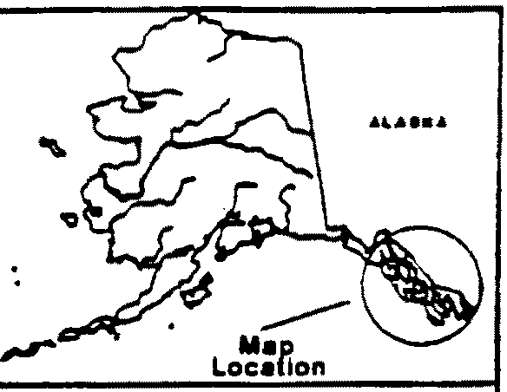

''

,, 1 Berners River

2 Auke Lake

3 Ford Arm Lake

4 Hugh Smith Lake

I

I I

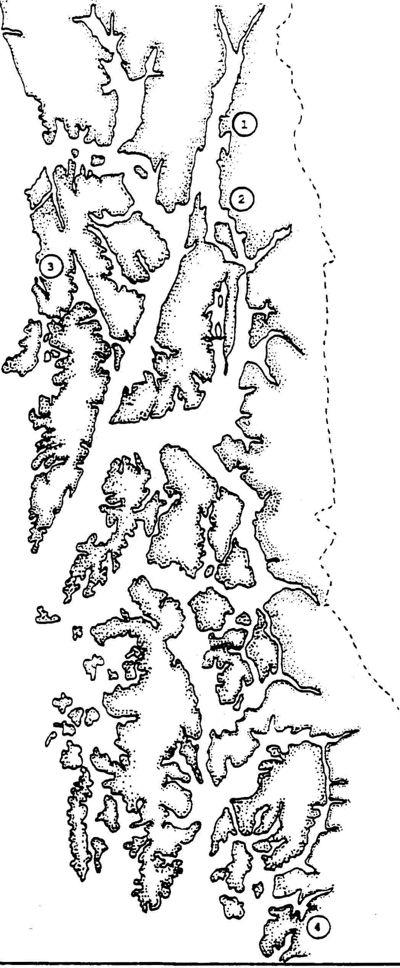

Figure 1. Map of Southeastern Alaska showing the locations of the Berners

River, Auke Creek, Ford Arm Lake, and Hugh Smith Lake.

46

60,000

e-*ti)*

-

50,000

**::l**

� 40,000

-

**'iii**

*{:.*

**"C**

**i**

G)

....

88

30,000

20,000

83�

10,000

.........•.....

84

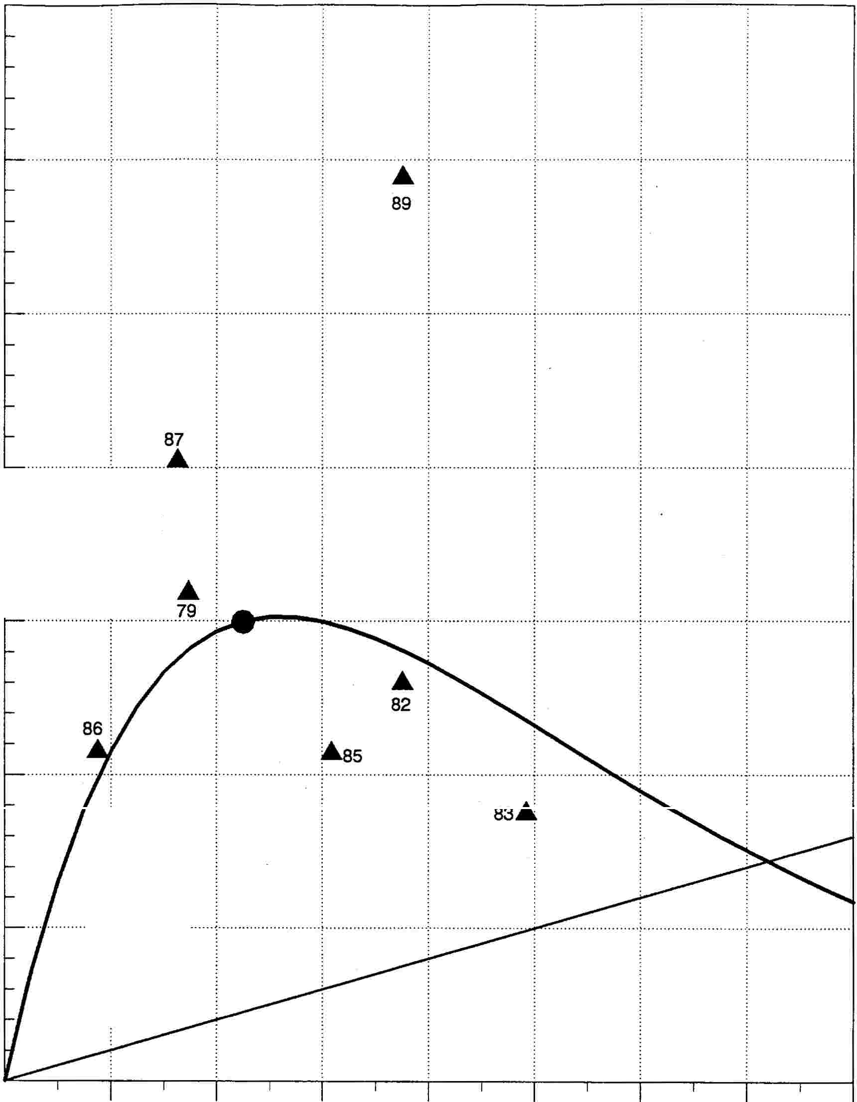

2,000 4,000 6,000 8,000 10,000 12,000 14,000

.

**Estimated Spawner Abundance**

....

1979-1989 Spawner-Recruit Replacement Optimal

Figure 2. Spawner-recruit relationship for Berners River coho salmon using unadjusted total returns.

47

10

5

0

(5)

0.5

Deviations from Average Percent Survival

(mean = 14.5%)

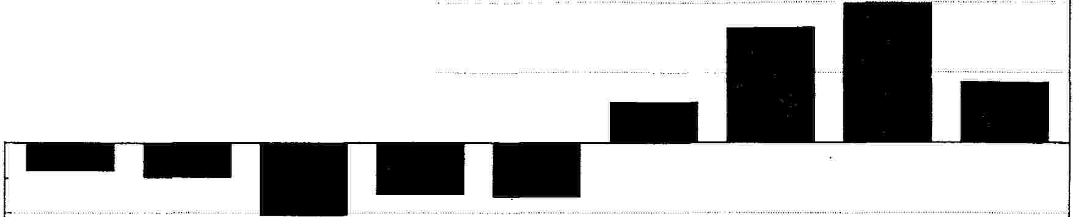

1979 1982 1983 1984 1985 1986 1987 1988 1989

Residuals in Spawner-Recruit Relationship (Ln[R/S])



**ot-"'-L._-.--**

(0.5)

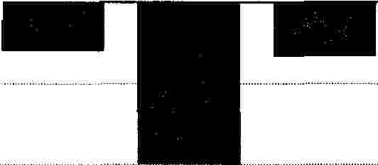

(1)

1979 1982 1983 1984 1985 1986 1987 1988 1989

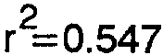

a.

..c:

C/l

c:

0

� 0.5

(I)

a:

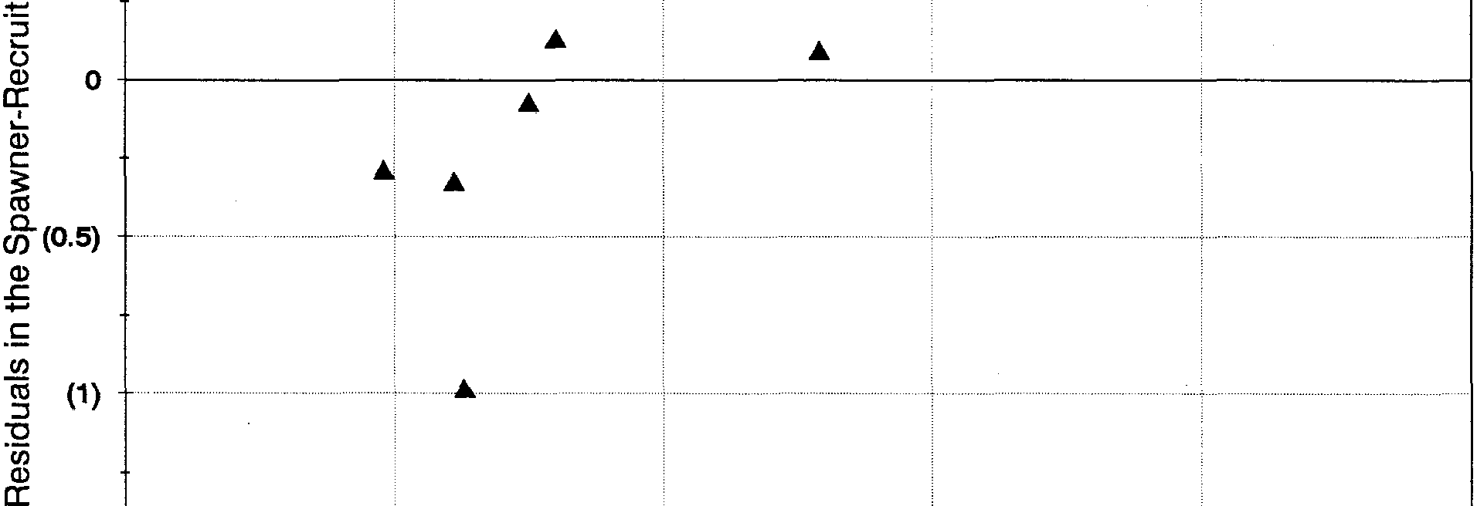

(5) 0 5 10

Deviations from Mean Percent Survival (Mean = 14.5%)

Figure 3. Deviations from average marine survival and residuals in the spawner•

recruit relationship for Berners River coho salmon.

48

• r =0.588 • •

2

• a=2.49389 • • Pm=19,316. • Avg. Marine Survival= 14.5%



60,000

*ti)* **c** "::':",

50,000

**A**

89

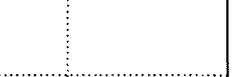

� 40,000

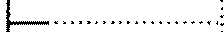

-

-ca .. ..

�

**'tJ**

**i**

Cl)

':;:::;

*ti)*

w

30,000

Exp. Rate @ OY = 81.4%

1-.. - .. -,

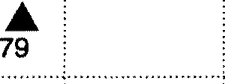

• 82.A..

.. �..... .

:as

.....•

83.

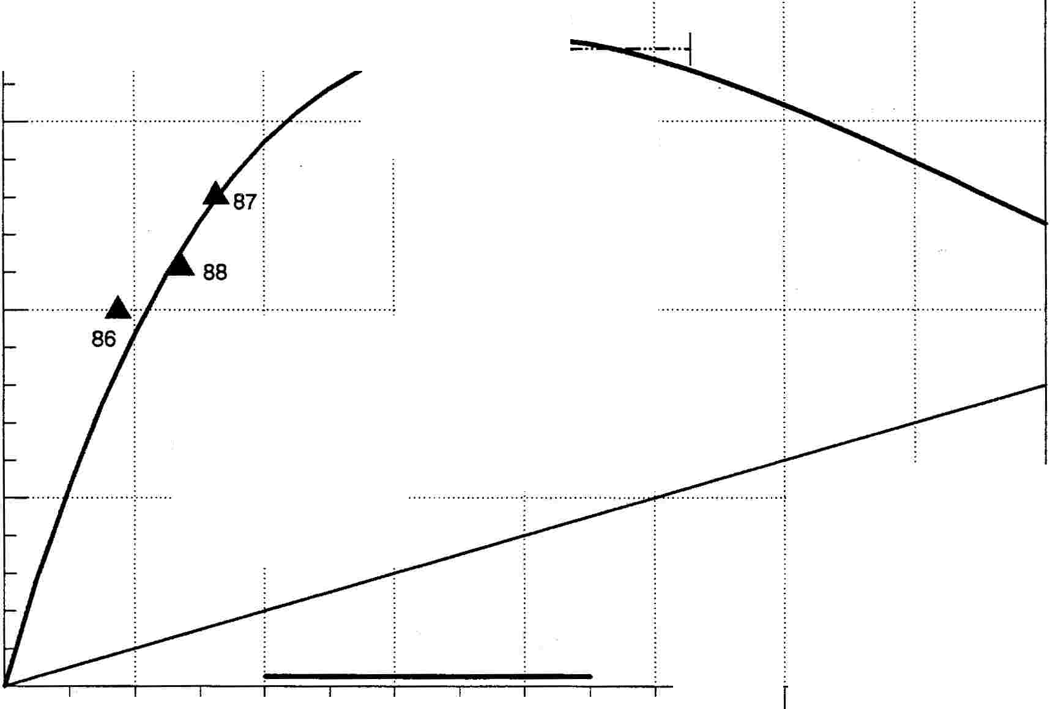

20,000

**A**

84 .. ..

..

..

)

.. ..

10,000

.... �.· ' · . ·.

90 91 92 93

2,000 4,000 6,000 8,000 10,000 12,000 14,000

.

**Estimated Spawner Abundance**

-··-"'-··-··-

90% Cl Opt Spawner-Recruit Replacement 1990-1993 Escap's 90% + Yield

•

Optimal

Figure 4. Spawner-recruit relationship for Berners River coho salmon using total returns adjusted to average marine survival conditions.

49

60,000

en so,ooo

...

:i

i

0: 40 000

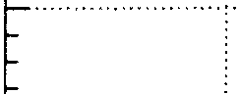

iii •

�

i 30,000

ii

E

i

10,000

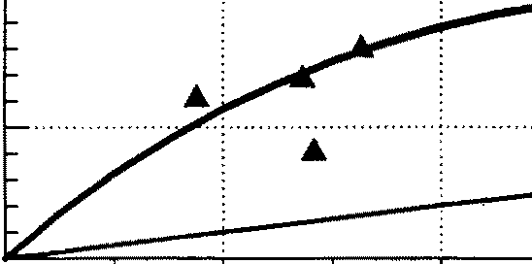

1

Total Returns AdJusted to Low Marine Survival (8.8%) •

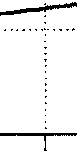

2,000 4,000 6,000 8,000 10,000

. Estimated Spawner Abundance

197�989 Spa�rult Replacement 01\mal

12,000 . 14,000

.. ..

.. ..

.. .. ..

60,000

en so,ooo

c

i

� 40,000

:I

�

"Cl

.; 30,000

E

! 20,000

. . . . . . .

Total Returns Adjusted to High Marine Survival (21.1 %)

...

··········;-···················

2,000 4,000 6,000 8,000 10,000

Estimated Spawner Abundance

12,000 14,000

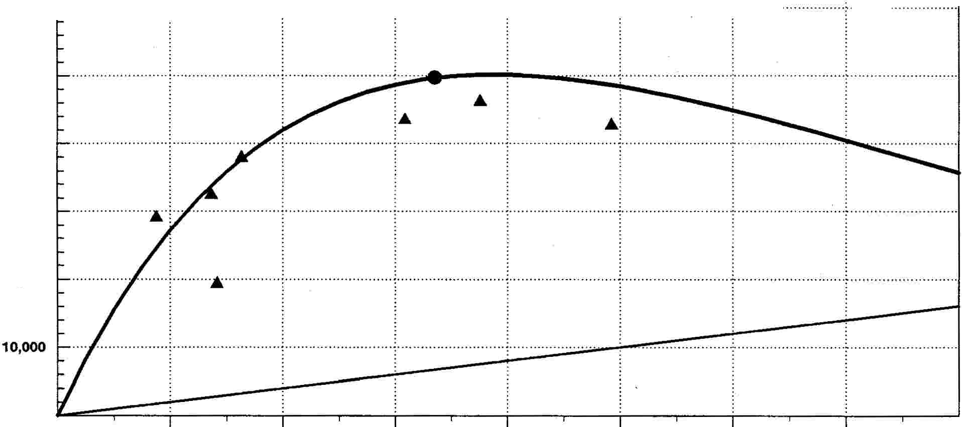

197�989 Spa�rult Replacement Op,mal

Figure 5. Spawner-recruit relationship for Berners River coho salmon using total returns adjusted to low and high marine survival conditions.

50

2,500

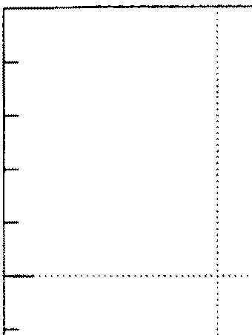

Cl)

**a:s.**

**G)**

**a:**

**'***e*.**i**.**i**.

**"O**

**G)**

**as E iw**

2,000

1,500

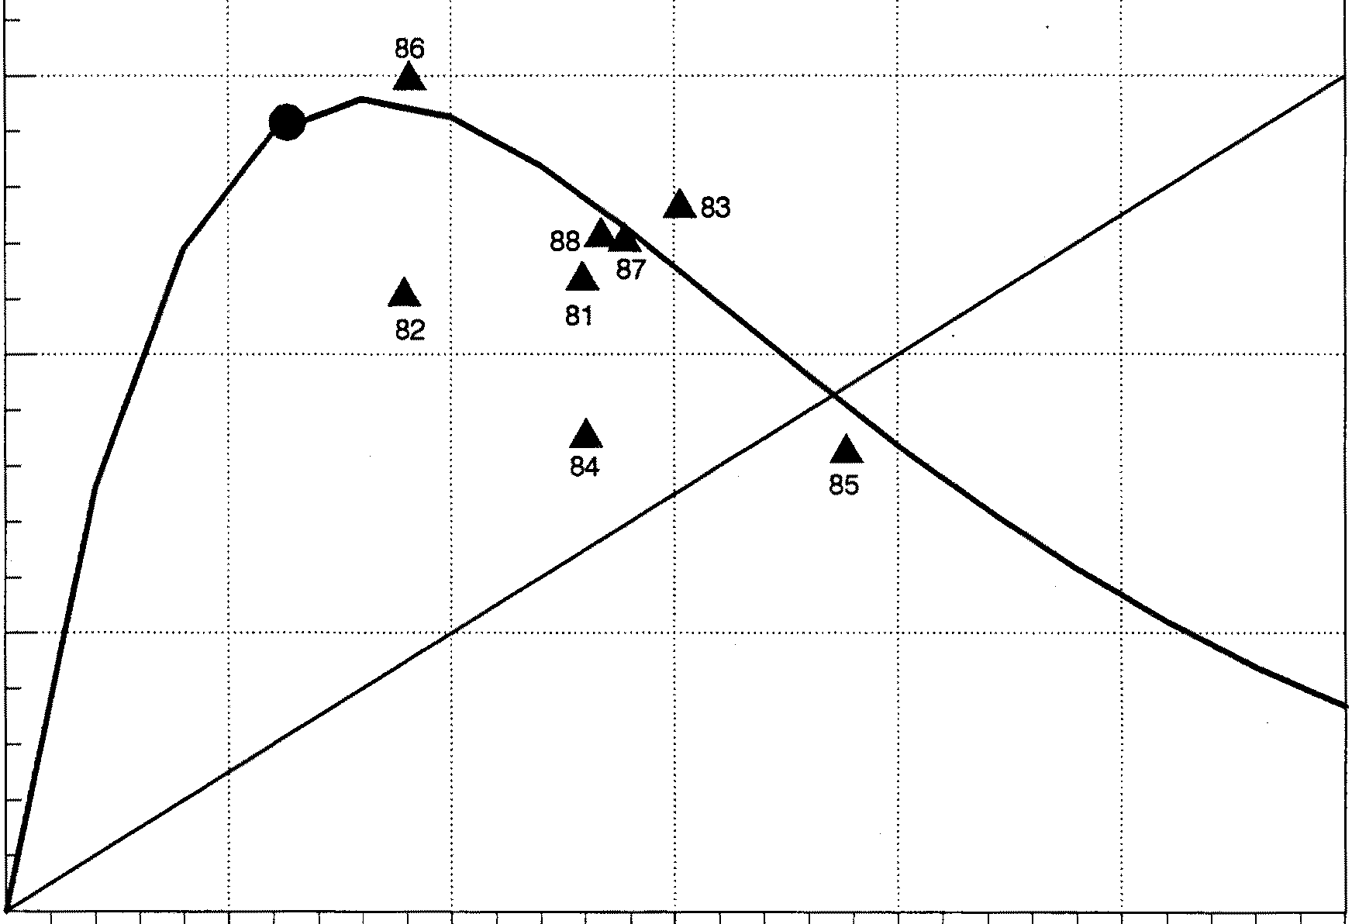

1,000

500

............................................89 ...............•.... : .

80

250 500 750 1,000

**Estimated Spawner Abundance**

1980•-1989 Spawner-Recruit Replacement Op•timal

1,250

Figure 6. Spawner-recruit relationship for Auke Creek coho salmon using

unadjusted total returns.

51

Deviations from Average Percent Survival

6

(mean= 17.1%)

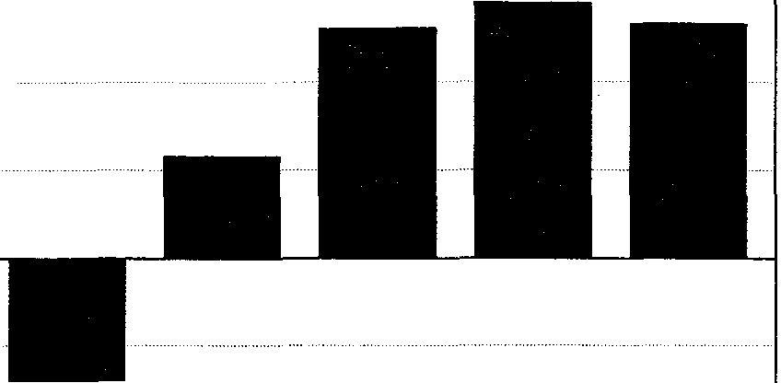

4

2



O>-----

(2)

1980 1981 1982 1983 1984 1985 1986 1987 1988 1989

0.4

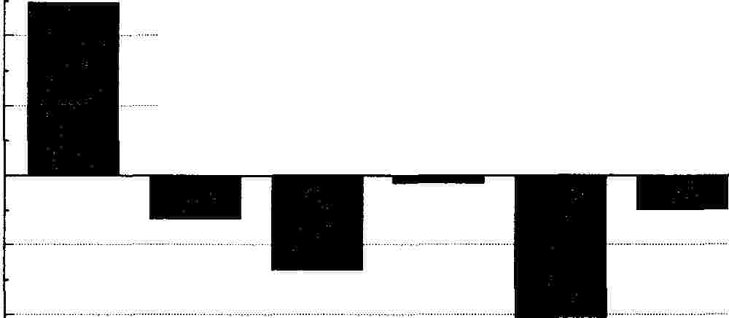

0.2

0

(0.2) (0.4)

Residuals in Spawner-Recruit Relationship (Ln[R/S])



1980 1981 1982 1983 1984 1985 1986 1987 1988 1989

•

Q.

*:E en* c

0

':.::;

ctl a5 a:

:!:::::

:.:.:.:.,

0.4

r2=0.080 •

•

0 0.2

Q)

a:

..I..

Q)

c

• •

� 0

*e*Q*n*. •

Q)

..s.:.:.:.

c (0.2)

*en* •

ro

::::,

'O

'cii (0.4)

Q)

a:

;

•

(2) 0 2 4 6

Deviations from Mean Percent Survival (Mean = 17.1 %}

•

Figure 7. Deviations from average marine survival and residuals in the spawner•

recruit relationship for Auke Creek coho salmon.

52

r =0.578 a=1.9291

2

Pm=932 •

Avg. Marine Survival = 17.1 %

2,500 ........................ ; ,.,:,,, .

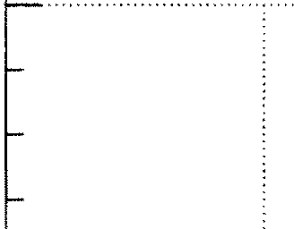

.... · : .

*ti)*

::,

-e-

2,000

80..

**a:**

G)

**"i**

**0** 1,500

-

I-

**"C**

G)

**ca**

**E**

;.

*ti)*

**w**

. .

Exp] Rate @ OY = 70j6%

it··

1,000

500

90 91 93 �2

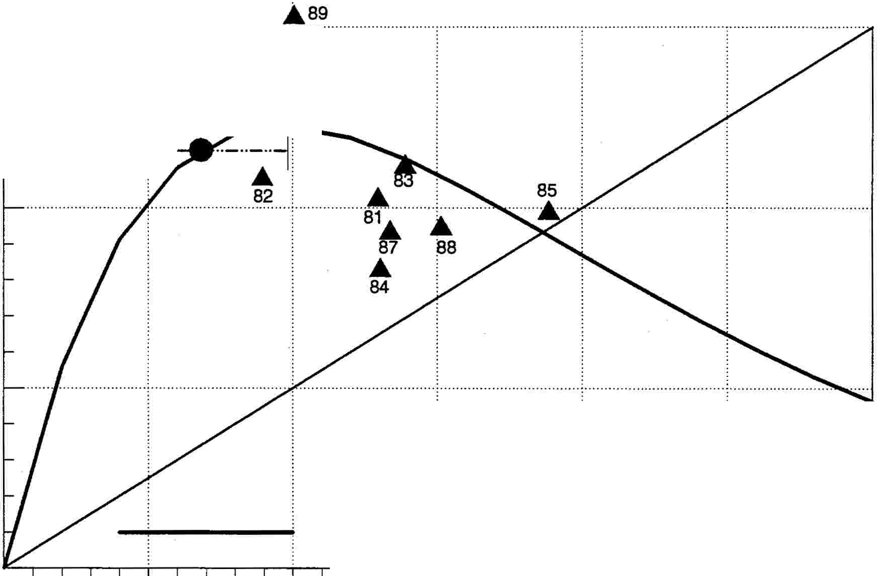

250 500 750 1,000

.

1,250

9_0%_ Cl ,Opt_

**Estimated Spawner Abundance**

Spawner-Recruit Replacement 1990-1993 Escap's 90% + Yield

ptimal

O

•

.. .. _, _,,_

Figure 8. Spawner-recruit relationship for Auke Creek coho salmon using total returns adjusted to average marine survival conditions.

53

2,500

: ; : : :



Total Returns Adjusted to Low Marine Survival (11.0%)

(I)

�.ooo

i

a:

ii

�.50o

i

7ii

E it,000 w

500

....

...

.... :

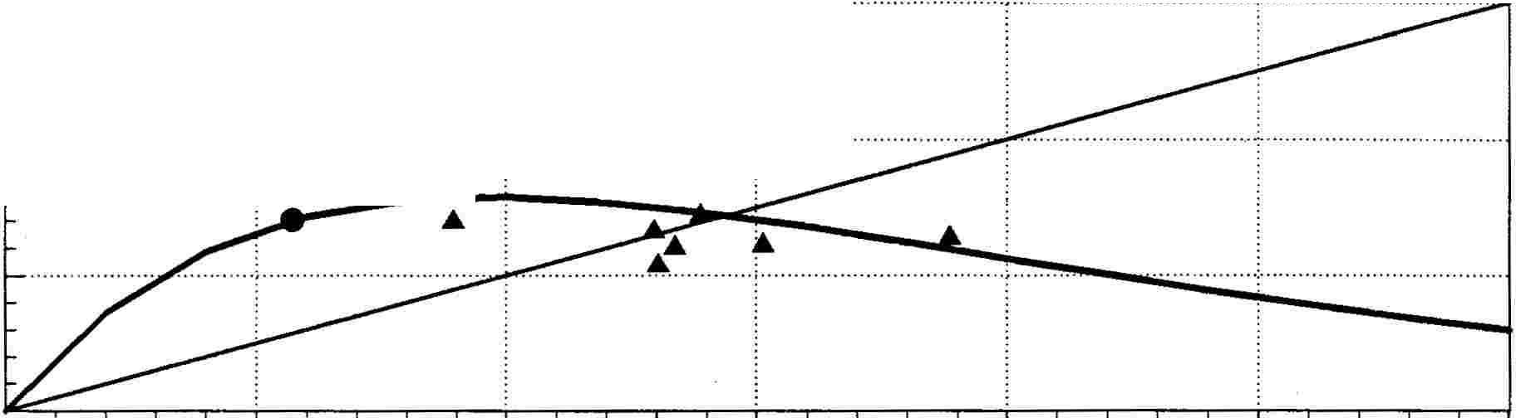

...............................................

250

500 750 1,000

.

Estimated Spawner Abundance

1980.-.1.989 Spa�wner-Recruit Re�plac�ement Optimal

1,250

Total Returns Adjusted to...High Marine Survival {22.4%)

:

2,500

..... �.· ········!.··············· . .

.: :. :.

.: ;.. :.

..

..

..

.. .. ..

..

..

..

.. . ..

(I)

!:2,ooo

:::J i a:

ii

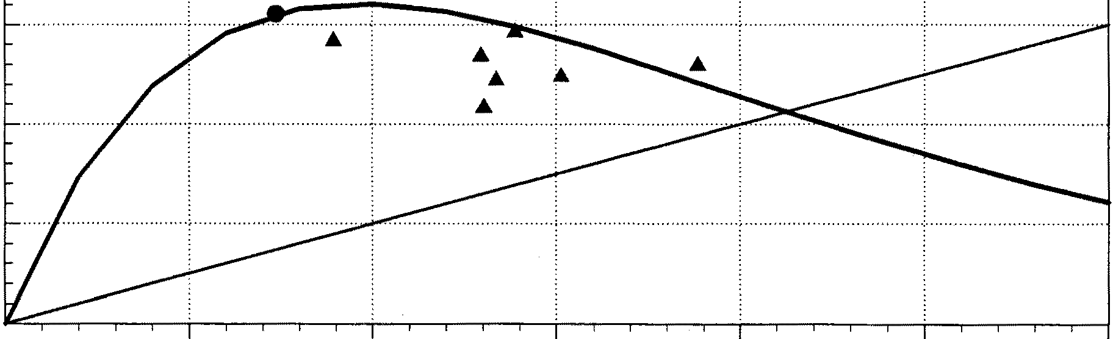

�,500

!

E

�.ooo

w

500

. . .

··································· \ \ .

250 500 750 1,000

Estimated Spawner Abundance

19�989 Spa�ruit Replacement Opjtal

1,250

Figure 9. Spawner-recruit relationship for Auke Creek coho salmon using total returns adjusted to low and high marine survival conditions.

54

12,000

10,000

*,n* **c i..**

-

**::s**

Cl) 8,000

**m**

-

**a:**

**0**

I-

-

...

89

**"C** Cl) **cu**

**E**

;;

*,n*

w

6,000

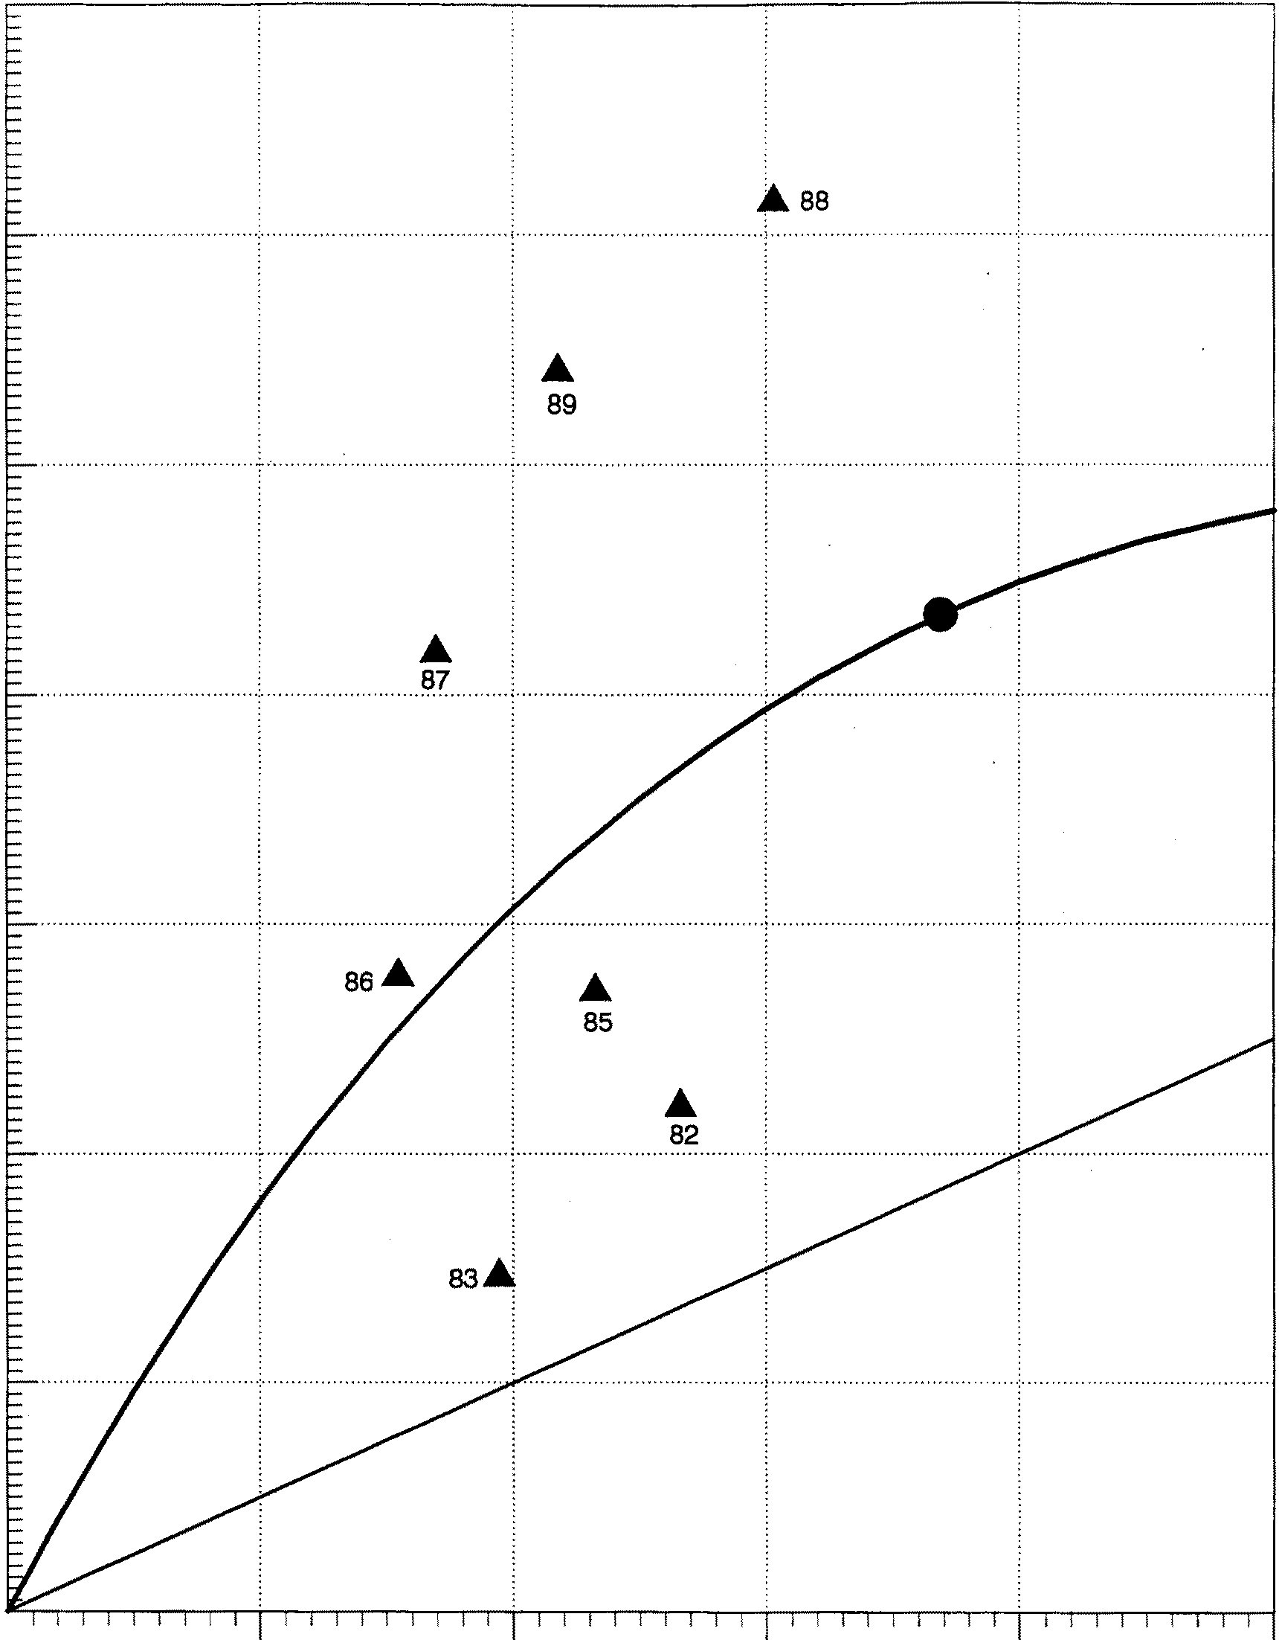

4,000

2,000

1,000 2,000 3,000 4,000

**Estimated Spawner Abundance**

...

1982-1989 Spawner-Recruit Replacement Optimal

Figure 10. Spawner-recruit relationship for Ford Arm Lake coho salmon using unadjusted total returns.

.

55

6

4

2

0 (2) (4)

Deviations from Average Percent Survival



(mean = 10.8%)



1982 1983 1985 1986 1987 1988 1989

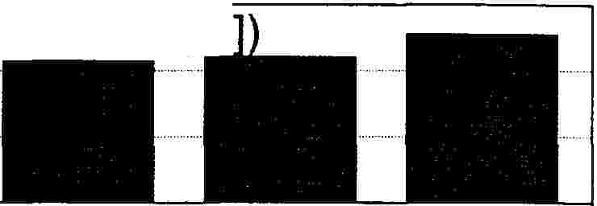

0.4

0.2

Residuals in Spawner-Recruit Relationship (Ln[R/S

0

(0.2) (0.4)

(0.6)

1985

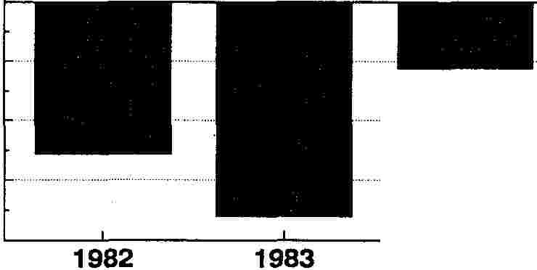

1986

1987

1988

1989

a.

.c rn c:

0

0.4

:.::;

rn

aa>:

:!=

0.2

.:.:.,. o aa>:

..I..

r2=0.810

a> 0

c:

r3n:

a.

©(0.2)

-

a>

.c

c:

·;;; (0.4)

rn

::, A

"*·e*O*n*

a> (0.6)

a:

A

� � 0 2 4 6

Deviations from Mean Percent Survival (Mean = 10.8%)

Figure 11. Deviations from average marine survival and residuals in the spawner•

recruit relationship for Ford Arm Lake coho salmon.

56

I r 2=0.ss1

• 8=1.82491

• Pm=S,508

[ Avg. Marine Survival = 10.8%

8,000

..&.87 •

.,&.82 Asa

*en*

-

e

:I:,:,s. 6,000

Exp. rate @ OY = 6$.1 % •

I-··-··-··-• ··-··-..-··-··-·!-··- ·-··-··-··-·I

89 •

G)

a:

-

m

0

.,-..,.

G)

ca

4,ooo

iw

E

2,000

1,000 2,000 3,000 4,000

.

Estimated Spawner Abundance

90% Cl Opt. Spawner-Recruit Replacement 1990-1993 Escap's 90% + Yield

-··-··-··-··-·

Optimal

•

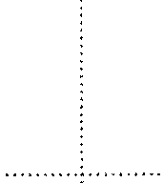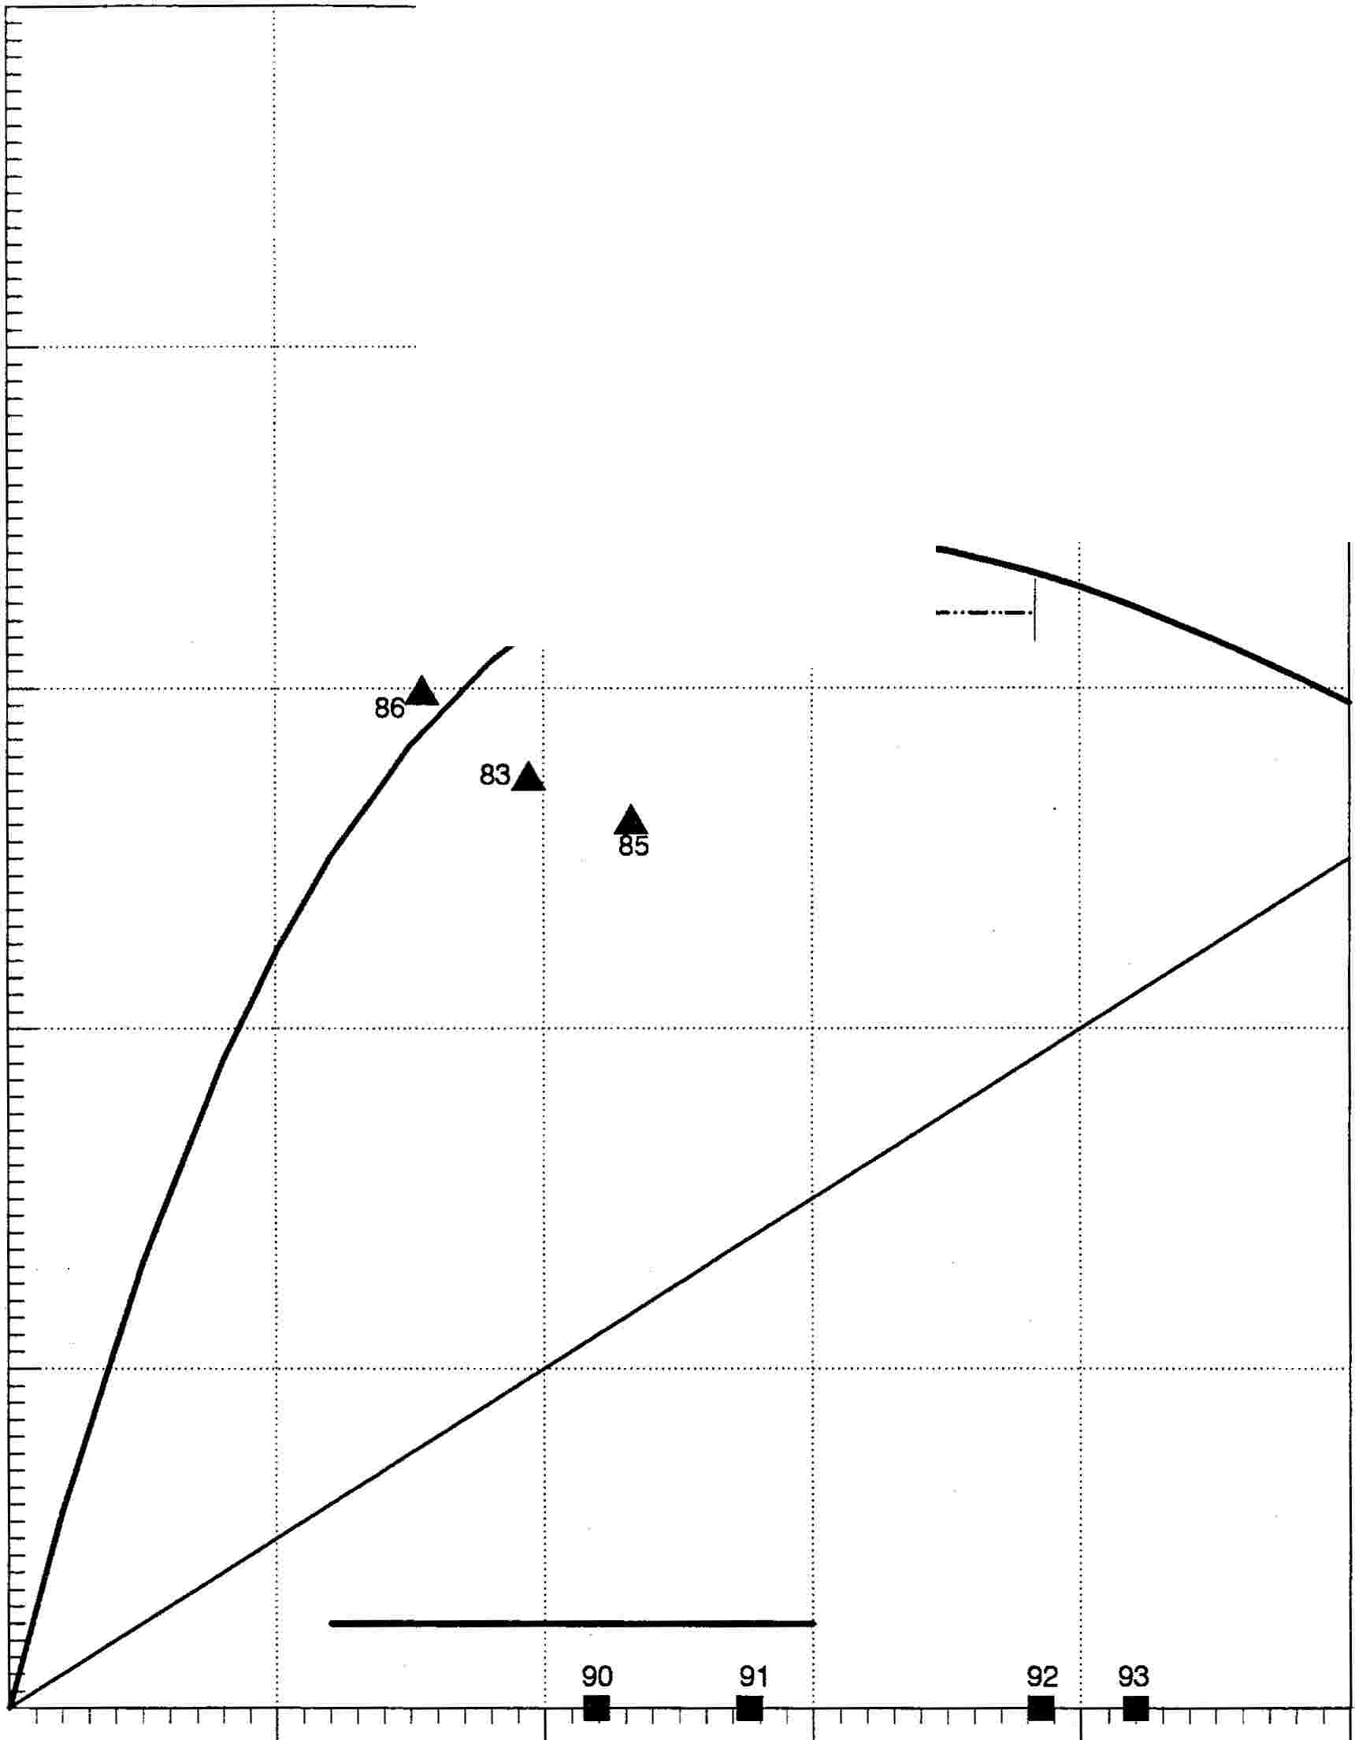

Figure 12. Spawner-recruit relationship for Ford Arm Lake coho salmon using total returns adjusted to average marine survival conditions.

57

Icll

10,000

: : : :

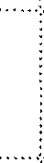

Total Returns Adjusted to Low Marine Survival (6.5%)

3 8,000

ii

a:

.�..

al

1ii

E

�

6,000

4,000

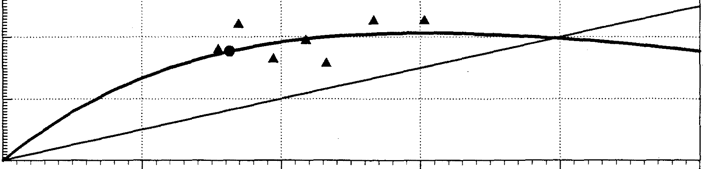

2,000

1,000 2,000 3,000

Estimated Spawner Abundance

1982..1989 Spa-wner-Recruit Re-plac-ement Optimal

- .

4,000

10,000

Total Returns Adjusted to High Marine Survival (15.7%)

: : ... � :

...

..... ·�. .. . .'... .. . . . . .. . . . . . . . . ., ' ..

Ill

E 8,000 ························

:I ai a:

1 6,000

i

E

! 4,000

·····1··············· ···························

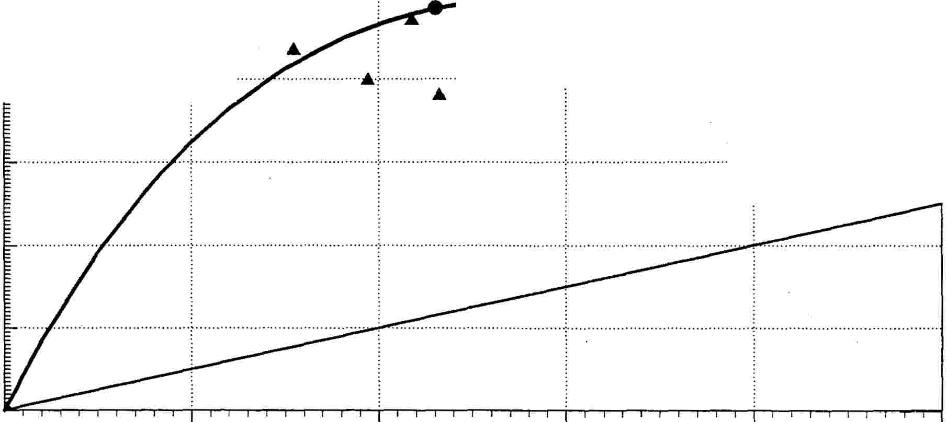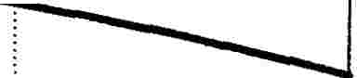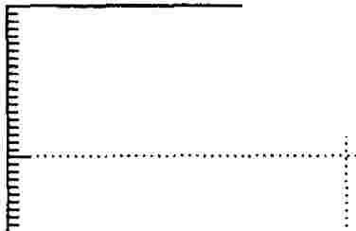

2,000

1,000 2,000 3,000 4,000

Estimated Spawner Abundance



Figure 13. Spawner-recruit relationship for Ford Arm Lake coho salmon using total returns adjusted to low and high marine survival conditions.

58

7,000

**.A**

87

6,000

0

..•.: .

88

**c** 5,000

**:i...**

**:::s**

**'S**

-

**a:**

**m**

89 .•..

{:_ 4,000

-

**"C**

**Cl)**

**ta .A E** 82 **an** 3,ooo

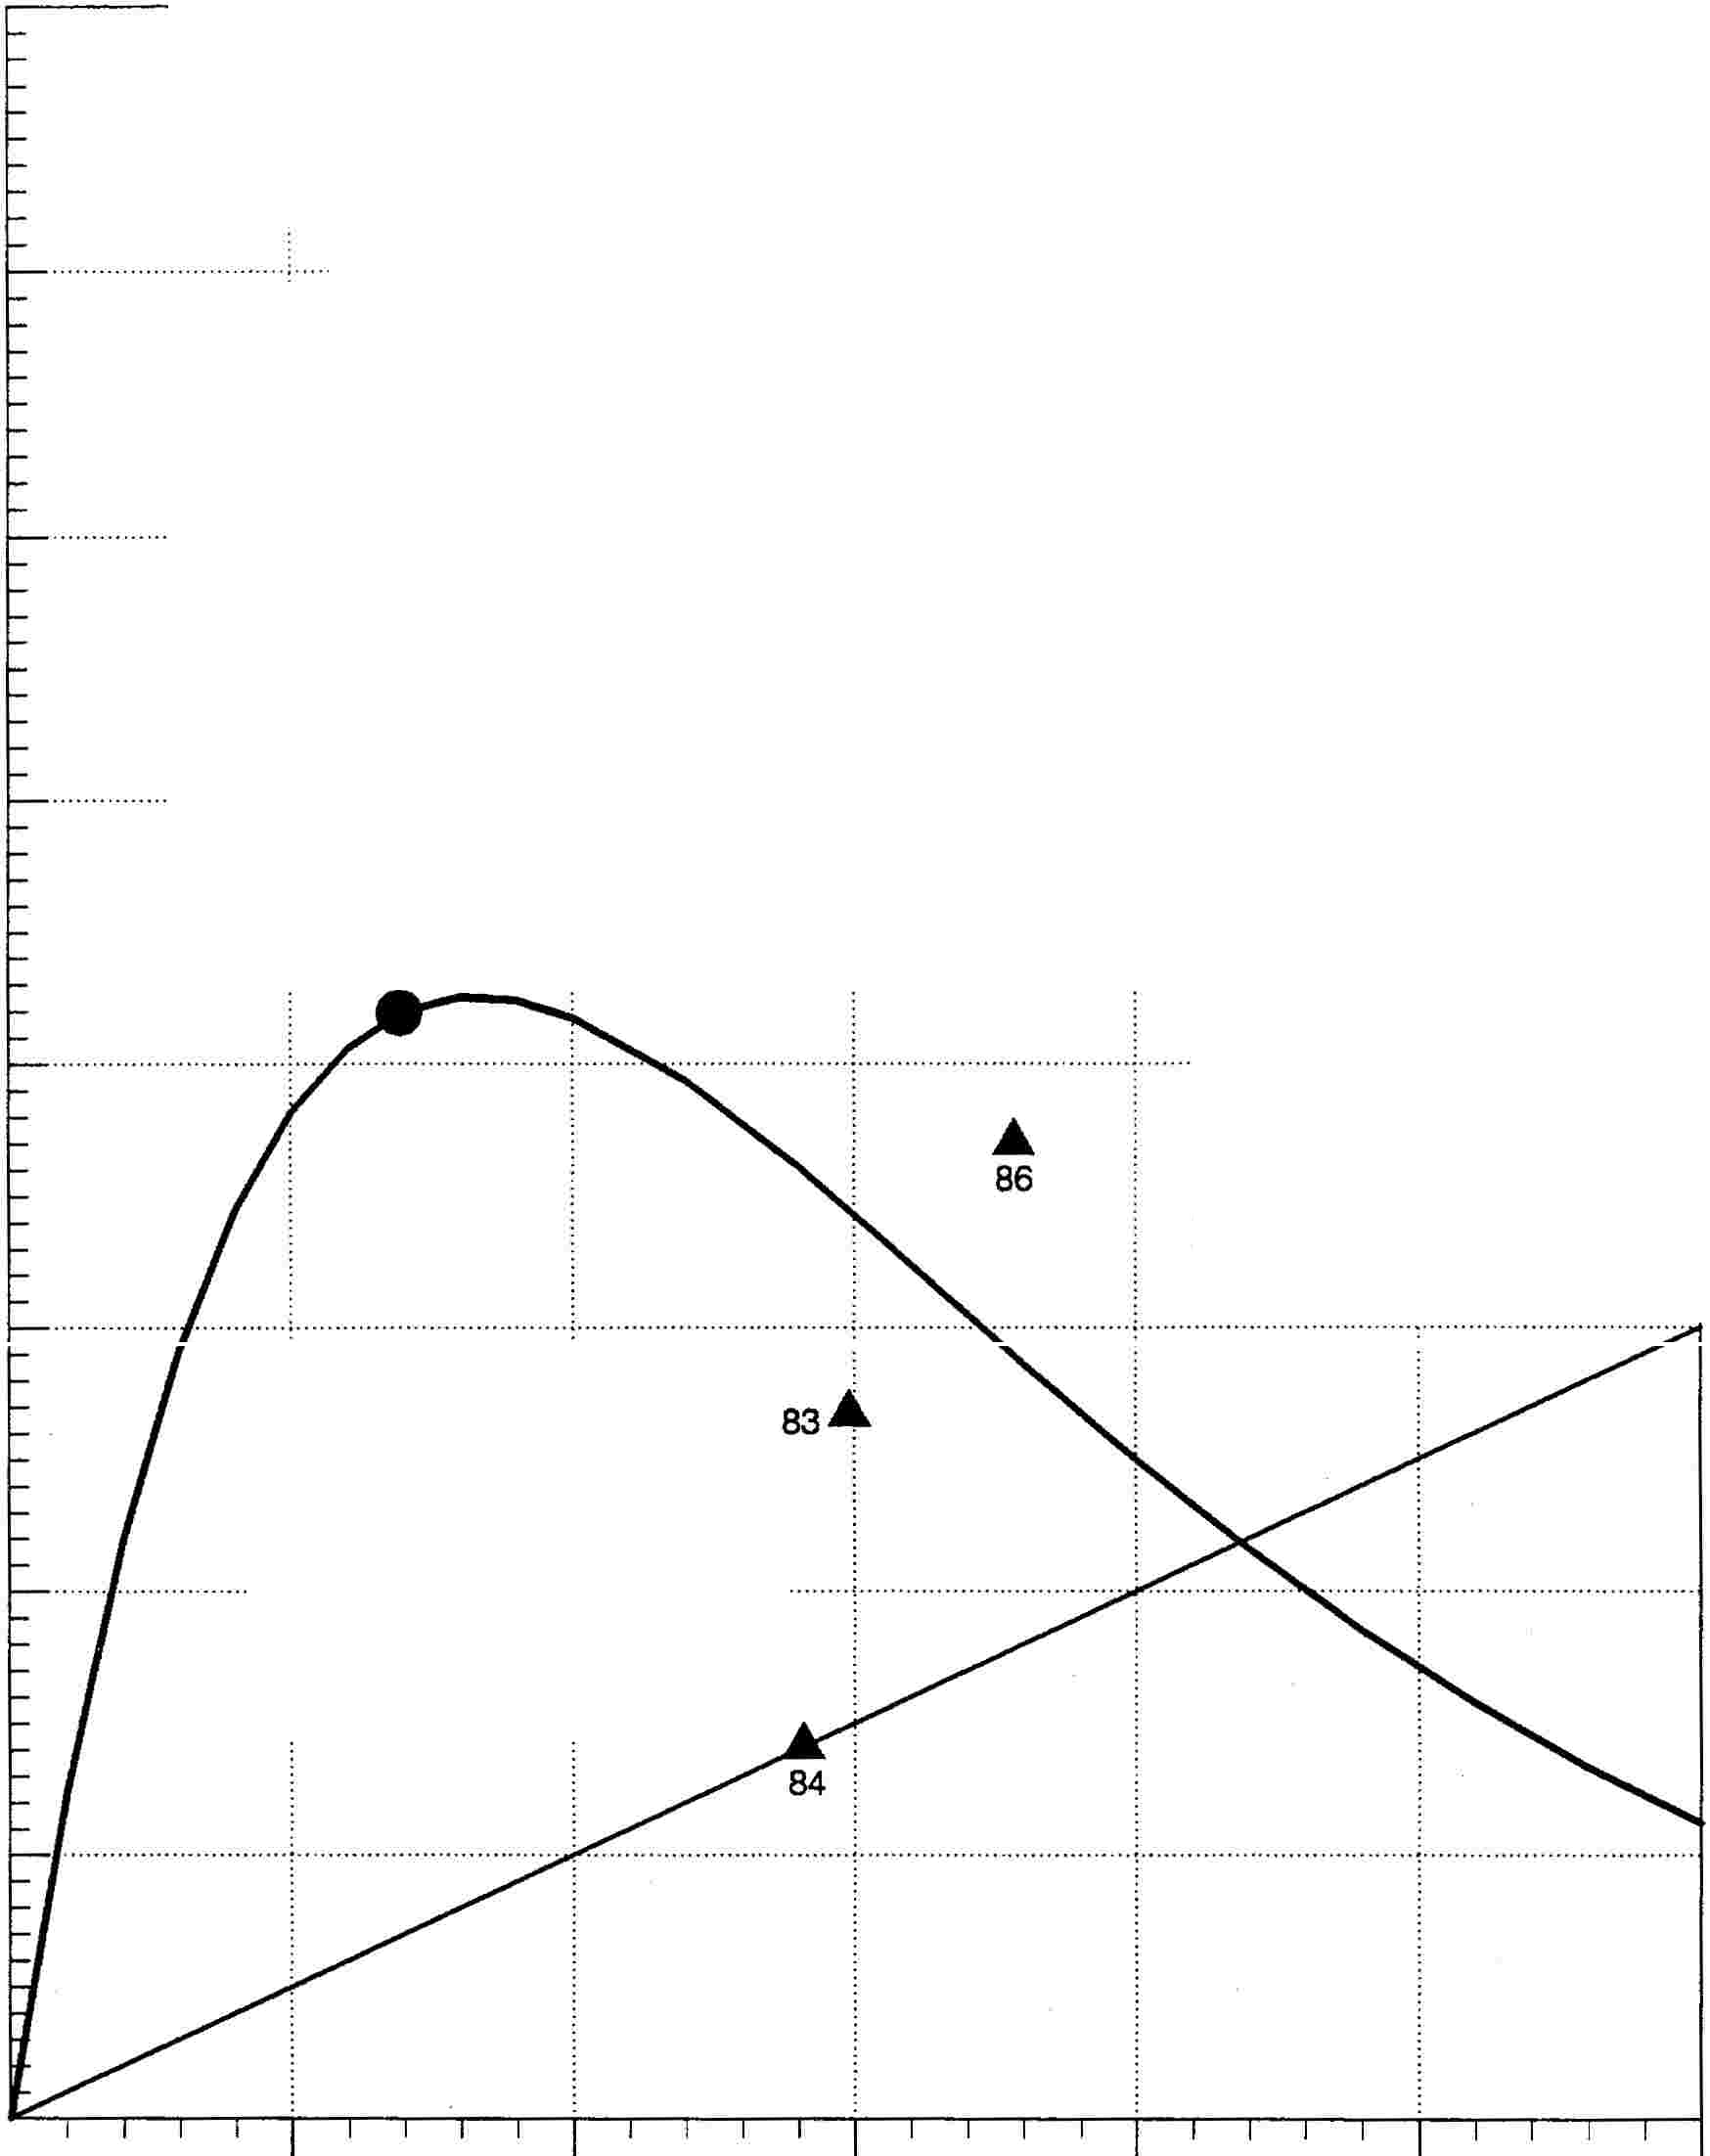

2,000

1,000

**.A**

85

I [

..••• j ••••••••••••••••.••••••••....•..... 1·· ·······················

500 1,000 1,500 2,000

**Estimated Spawner Abundance**

2,500

|  |  |  |
| --- | --- | --- |
| 1982-1989 | Spawner-Recruit Replacement | Optimal |
| **.A** |  | **•** |

Figure 14. Spawner-recruit relationship for Hugh Smith Lake coho salmon using unadjusted total returns.

59

6

4

2

0 (2) (4)

Deviations from Average Percent Survival

(mean = 12.8%) ·

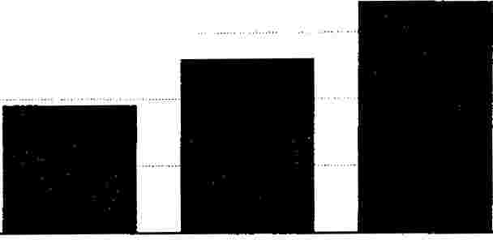

1982

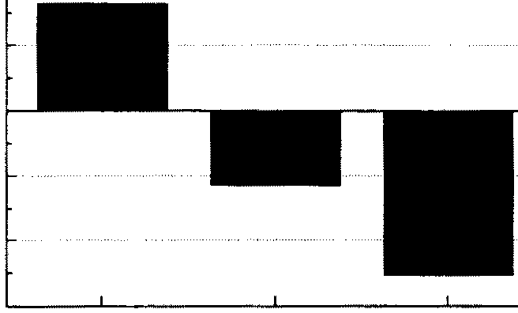

1983

1984

1985

1986

1987

1988

1989

0.5

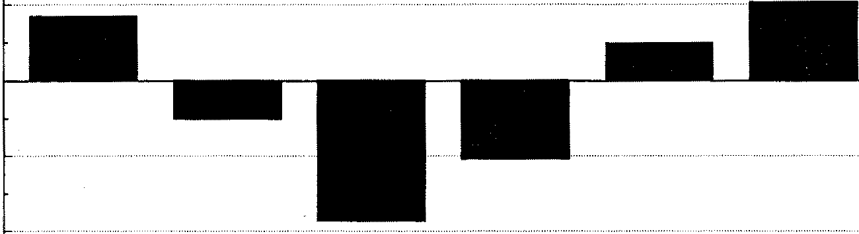

0 (0.5) (1)

Residuals in Spawner-Recruit Relationship (Ln[R/S])

1982 1983 1984 1985 1986 1987 1988 1989

.:t::

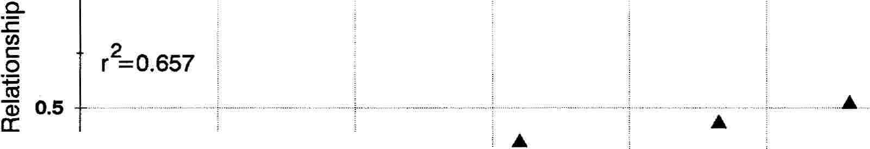

2 •

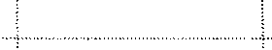

.,

0

Q)

�...

Q)

c

�

a.

*Cl)*

O-t-����������������������������----1

a>(0.5) · ,.,, .. · ·-.:

.c

+-'

c

!/)

ctS

-5 (1)

'iii

Q)

a:

(4) (2) 0 2 4 6

Deviations from Mean Percent Survival (Mean = 12.8%)

Figure 15. Deviations from average marine survival and residuals in the spawner•

recruit relationship for Hugh Smith Lake coho salmon.

60

2

r =0.859

7,000

a=2.46857

• PM=2,341

• Avg. Marine Surviva:l = 12.8% .

6,000

0

-

**:I**

...

.. ..

........ : : .

**E** 5,ooo

···r·········· ·····························

G)

***a;***

!

{:_ 4,000

**"C**

!

**E**

i 3,000

w

89 Exp. rate@ OY = 81.0%

483

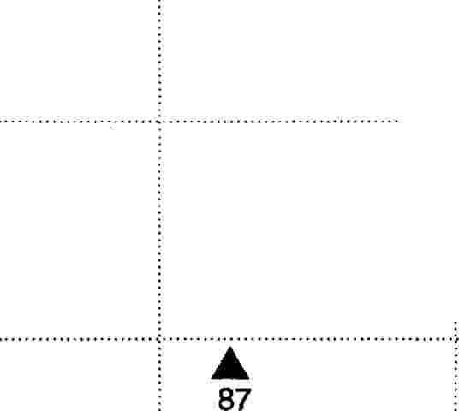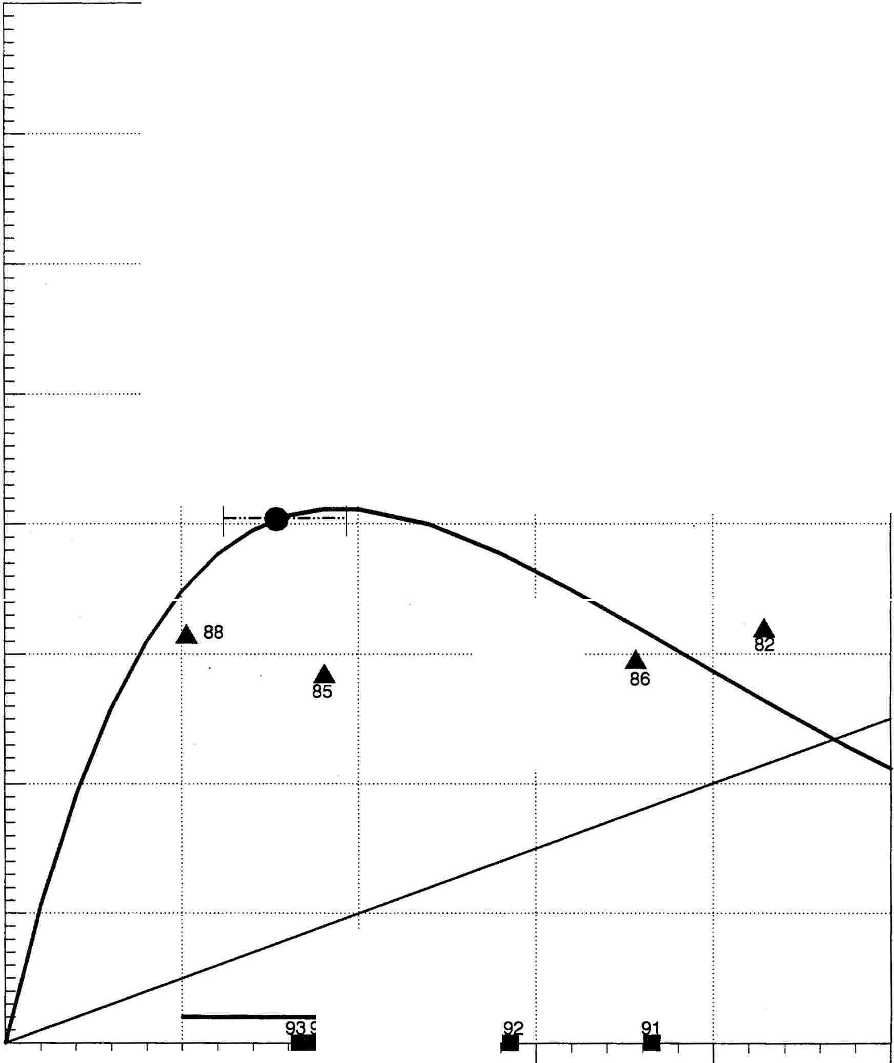

·····.··.··.·············· .

.

84

2,000

1,000

0

500 1,000 1,500 2,000

.

**Estimated Spawner Abundance**

90% Cl Opt. Spawner-Recruit Replacement 1990-1993 Escap's 90% + Yield

-··-··- .. -··-"

ptimal

O •

Figure 16. Spawner-recruit relationship for Hugh Smith Lake coho salmon using total returns adjusted to average marine survival conditions.

61

7,000

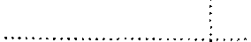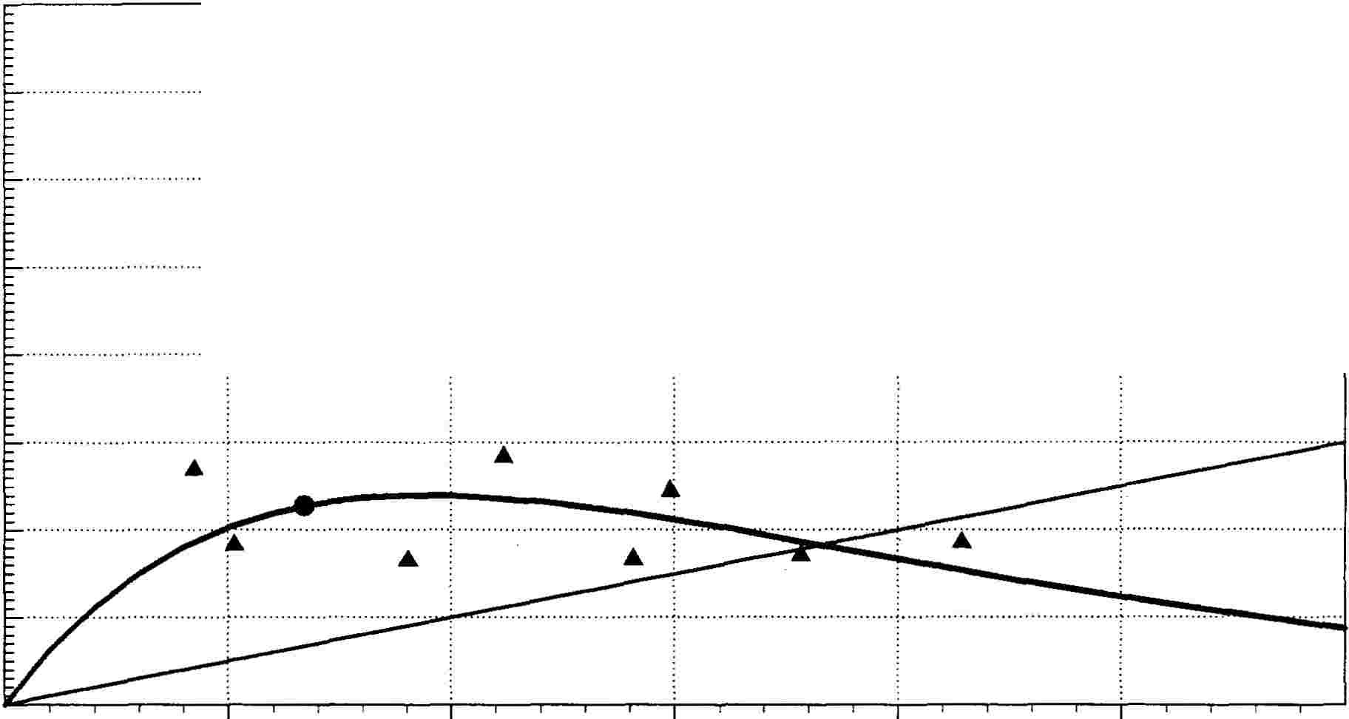

. . . . .

*ltl*

e

....

:I

6,000

T.otal Returns . Adjusted to .Low Marine S.

urvival (7.5%)

lj 5,000

a:

iii

� 4,000

E 3,ooo

!

�

2,000

1,000

500 1,000 1,500 2,000

Estimated Spawner Abundance

2,500



*ltl*

e

....

:I

7,000

6,000

. . . . .

Total Returns Adjusted to High Marineisurvival (18.7%)

. . . :.. . . ································

,

.... .

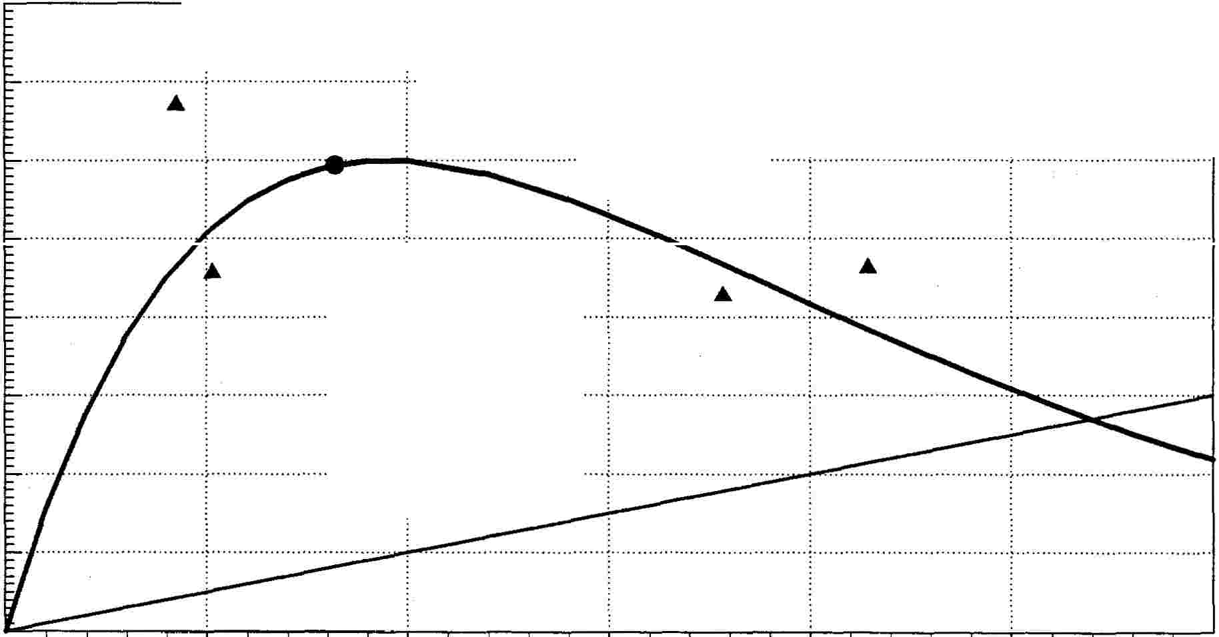

'aj 5,000

a:

!

{:. 4,000

E 3,ooo

!

�

·····-�·-··-:-·········· !'i-

2,000

1,000

500 1,000 1,500 2,000

Estimated Spawner Abundance

2,500

198�989 Spa�ruit Replacement O�mal

Figure 17. Spawner-recruit relationship for Hugh Smith Lake coho salmon using total returns adjusted to low and high marine survival conditions.

62

16,000

a> 14,000

o c a,

Berners River Coho Salmon

....

Q) o ca,

1,000 -

Auke Creek Coho Salmon

....

....

-g12,ooo

:::,

..0

<

ci>10,000

c

�

�B,000

"tl

Q)

� 6,000

�

w 4,000

2,000

....

....

*t:. ...*

�

ti

*... ···1:;.*

......! ..

-g 800 - ...

:::,

.-.c0

Q)

c

� 600 -

a.

(/)

1 400 _ -I······

�

200 -



.....

|  |  |  |  |  |
| --- | --- | --- | --- | --- |
|  | | I | I | I |
| 90% C.I. for Opt. 1979-198& Escap's  Opti:um 1990-199,l Escap's | 90% + Yield  Optifum | 90% C.I. for Opt  Opti:um | 1979-19ag Escap's  1990-199,l Escap's | 90% + Yield  Opti:um |

Q) o c a,

"tl

c

:::,

Ford Arm Lake Coho Salmon

....

....

Q) o c a,

"tl

c

::,

2,000 -

Hugh Smith Lake Coho Salmon

�3,000

Q)

c

a.

(/)

-02,000

Q)

'lii

E

�

w

1,000

.............................................. .!:,. ..

6

•

*=r=c:':*

6

6

··················· ..

�1,500 ....

Q)

c

�

a.

I

�1.000 -

'lii

i

Q)

w

500 -······ ·

··············!:,

�

....6.

6

.............. ·········- ·······•·····

•

|  |  |  |  |  |
| --- | --- | --- | --- | --- |
|  | | I | I | I |
| 90% C.I. for Opt 1979-198g Escap's  Opt�um 1990-1� Escap's | 90% + Yield  Opti:um | 90% C.I. for Opt  Opti:um | 1979-198& Escap's  1990-199.l Escap's | 90% + Yield  Opti:um |

Figure 18. Comparison of coho salmon escapements to those ranges calculated to represent the 90% confidence interval for the optimum and to represent 90% or more of the maximum yield for four stocks.

63

APPENDIX TABLES

64

Appendix Table 1. Estimated age composition of coho salmon returning to the

Berners River, 1982-1993.

PART l; Age Composition of Berners River Coho Salmon (No. of sampled fish):

|  |  |  |  |  |  |  |  |
| --- | --- | --- | --- | --- | --- | --- | --- |
| Return Year | Number  Age 3 | of Fish  Age 4 | Sam2led by  Age 5 | Age  Age 6 | To  Number | t.al of | Fish Sam2led |
| 1982 | 95 | 210 | 26 | 0 |  |  | 331 |
| 1983 | 137 | 413 | 81 | 5 |  |  | 636 |
| 1984 |  |  |  |  |  |  | 0 |
| 1985 | 121 | 214 | 22 | 2 |  |  | 359 |
| 1986 | 60 | 198 | 21 | 0 |  |  | 279 |
| 1987 | 67 | 478 | 11 | 0 |  |  | 556 |
| 1988 | 241 | 231 | 3 | 0 |  |  | 475 |
| 1989 | 130 | 297 | 14 | 0 |  |  | 441 |
| 1990 | 250 | 211 | 7 | 0 |  |  | 468 |
| 1991 | 212 | 362 | 7 | 0 |  |  | 581 |
| 1992 | 253 | 282 | 5 | 0 |  |  | 540 |
| 1993 | 137 | 388 | 5 | 0 |  |  | 530 |

PART 2; Age Composition of Berners River Coho Salmon as Percent of Total Run:

Estimated Percent Age Com2osition

|  |  |  |  |  |  |
| --- | --- | --- | --- | --- | --- |
| Return Year  1982 | Age 3  28.7% | Age 4  63.4% | Age 5  7.9% | Age 6  0.0% | Total  100.0% |
| 1983 | 21.5% | 64.9% | 12. 7%- | 0.8% | 100.0% |
| 1984 |  |  |  |  | 100.0% |
| 1985 | 33. 7% | 59.6% | 6 .1% | 0.6\ | 100.0% |
| 1986 | 21.5% | 71.0% | 7.5% | 0.0% | 100.0% |
| 1987 | 12 .1% | 86.0% | 2.0% | 0.0% | 100.0% |
| 1988 | 50. 7% | 48.6% | 0.6% | 0.0% | 100.0% |
| 1989 | 29.5% | 67.3% | 3.2% | 0.0% | 100.0% |
| 1990 | 53.4% | 45.1% | 1.5% | 0.0% | 100.0% |
| 1991 | 36.5% | 62.3% | 1.2% | 0.0% | 100.0% |
| 1992 | 46.9% | 52.2% | 0.9% | 0.0% | 100.0% |
| 1993 | 25.8% | 73.2% | 0.9% | 0.0% | 100.0% |
| Averages | 32.8% | 63 .1% | 4 .1% | O.H | 100.0% |

65

Appendix Table 2. Estimated age composition of coho salmon returning to Auke

Creek, 1982-1993.

PART l; Age Composition of Auke Creek Coho Salmon (No. of sampled fish):

|  |  |  |  |  |  |  |  |
| --- | --- | --- | --- | --- | --- | --- | --- |
| Return Year | Number of  Age 3 Age 4 | | Fish SamQled by Age To  Age 5 Age. 6 Age 7 Number of | | | tal  Fis | h SamQled |
| 1982 | 66 | 87 | 15 | 0 | 0 | 168 | |
| 1983 | 106 | 275 | 2 | 0 | 0 | 383 | |
| 1984 | 37 | 325 | 20 | 0 | 0 | 382 | |
| 1985 | 6 | 69 | 58 | 12 | 1 | 146 | |
| 1986 | 22 | 142 | 38 | 3 | 0 | 205 | |
| 1987 | 14 | 61 | 29 | 4 | 0 | 108 | |
| 1988 | 7 | 152 | 97 | 11 | 0 | 267 | |
| 1989 | 187 | 449 | 11 | 0 | 0 | 647 | |
| 1990 | 32 | 121 | 0 | 0 | 0 | 1.53 | |
| 1991 | 36 | 117 | 0 | 0 | 0 | 153 | |
| 1992 | 70 | 175 | 5 | 0 | 0 | 250 | |
| 1993 | 36 | 345 | 13 | 0 | 0 | 394 | |

PART 2; Age Composition of Auke Creek Coho Salmon as Percent of Total Run:

|  |  |  |  |  |  |  |  |
| --- | --- | --- | --- | --- | --- | --- | --- |
| Return | Year | Age 3 | Estimated  Age 4 | Percent Age  Age 5 | Comgositi  Age 6 | on  Age 7 | Total |
| 1982 |  | 39.3% | 51. 8% | 8.9% | 0.0% | 0.0% | 100.0% |
| 1983 |  | 27.7% | 71. 8% | 0.5% | 0.0% | 0.0% | 100.0% |
| 1984 |  | 9. 7% | 85.1.% | 5.2% | 0.0% | 0.0% | 1.00.0% |
| 1985 |  | 4.1.% | 47.3% | 39. 7% | 8.2% | 0. 7% | 100.0% |
| 1986 |  | 10. 7% | 69.3% | 18.5% | 1. 5% | 0.0% | 100.0% |
| 1987 |  | 13.0% | 56.5% | 26.9% | 3. 7% | 0.0% | 1.00.0% |
| 1.988 |  | 2.6% | 56.9% | 36.3% | 4 .1% | 0.0% | 100.0% |
| 1989 |  | 28.9% | 69.4% | 1. 7% | 0.0% | 0.0% | 100.0% |
| 1990 |  | 20.9% | 79.1.% | 0.0% | 0.0% | 0.0% | 1.00.0% |
| 1991 |  | 23.5% | 76.5% | 0.0% | 0.0% | 0.0% | 100.0% |
| 1992 |  | 28.0% | 70.0% | 2.0% | 0.0% | 0.0% | 100.0% |
| 1993 |  | 9.1% | 87.6% | 3.3% | 0.0% | 0.0% | 100.0% |

Averages 18.1% 68.4% 11.9% 1. 5% 0.1% 100.0%

66

Appendix Table 3. Estimated age composition of coho salmon returning to Ford

Arm Lake, 1985-1993.

PART l; Age Composition of Ford Arm Lake Coho Salmon {No. of sampled fish): Number of Fish Sam12led bJ!: Age Total

Return Year Age 3 Age 4 Age 5 Age 6 Age 7 Number of Fish Sam12led

|  |  |  |  |  |  |  |
| --- | --- | --- | --- | --- | --- | --- |
| 1985 | 15 | 112 | 198 | 84 | 13 | 422 |
| 1986 | 51 | 254 | 112 | 10 | 0 | 427 |
| 1987 | 23 | 178 | 270 | 28 | 1 | 500 |
| 1988 | 42 | 329 | 99 | 4 | 0 | 474 |
| 1989 | 18 | 200 | 119 | 2 | 0 | 339 |
| 1990 | 37 | 323 | 110 | 0 | 0 | 470 |
| 1991 | l.07 | 1,758 | 624 | 1.0 | 0 | 2,499 |
| 1992 | 32 | l.,789 | 1,124 | 28 | 0 | 2,973 |
| 1993 | 25 | 2 073 | 1 901 | 52 | 0 | 4 051 |

PART 2; Age Composition of Ford Arm Lake Coho Salmon as Percent of Total Run:

|  |  |  |  |  |  |  |  |
| --- | --- | --- | --- | --- | --- | --- | --- |
| Return  1985 | Year | Age 3  3.6% | Estimated  Age 4  26.5% | Percent Age  Age 5  46.9% | Com12osition  Age 6  19.9% | Age 7  3.1%- | Total  100.0% |
| 1986 |  | 11. 9%- | 59.5% | 26.2% | 2.3% | 0. 0% | 100.0% |
| 1987 |  | 4.6% | 35.6% | 54.0% | 5.6% | 0.2% | 100.0% |
| 1988 |  | 8.9% | 69.4% | 20.9% | 0.8% | 0.0% | 100.0% |
| 1989 |  | 5.3% | 59.0% | 35 .1% | 0.6% | 0.0% | 100.0% |
| 1990 |  | 7.9% | 68. 7% | 23.4% | 0.0% | 0.0% | 100.0% |
| 1991 |  | 4.3% | 70.3% | 25.0% | 0.4% | 0.0% | 100.0% |
| 1992 |  | 1.1% | 60.2% | 37.8% | 0.9% | 0.0% | 100.0% |
| 1993 |  | 0.6% | 51.2% | 46.9% | 1. 3% | 0.0% | 100.0% |

Averages 5.3% 55.6% 35.1% 3.5% 0.0% 100.0%

67

Appendix Table 4. Estimated age composition of coho salmon returning to Hugh

*Smith* Lake, 1985-1993.

PART l; Age Composition of Hugh *Smith* Lake Coho Salmon (No. of sampled fish):

|  |  |  |  |  |  |  |  |  |  |
| --- | --- | --- | --- | --- | --- | --- | --- | --- | --- |
|  | Number of | | Fish Sam12led by | | Age | Total | | | |
| Return Year | Age 3 Age 4 | | Age 5 Age 6 | | Age 7 | Number | of | Fish | Samgled |
| 1985 | 64 | 253 | 188 | 16 | 0 |  | 521 | | |
| 1986 | 46 | 239 | 135 | 18 | 0 |  | 438 | | |
| 1987 | 26 | 252 | 103 | 6 | 1 |  | 388 | | |
| 1988 | 14 | 74 | 81 | 11 | 3 |  | 183 | | |
| 1989 | 33 | 119 | 54 | 0 | 0 |  | 206 | | |
| 1990 | 87 | 277 | 98 | 0 | 0 |  | 462 | | |
| 1991 | 132 | 1,365 | 152 | 6 | 0 |  | 1,655 | | |
| 1992 | 43 | 700 | 232 | 6 | 0 |  | 981 | | |
| 1993 | 28 | 356 | 62 | 2 | 0 |  | 448 | | |

PART 2; Age Composition of Hugh Smith Lake Coho Salmon as Percent of Total

Run:

|  |  |  |  |  |  |  |
| --- | --- | --- | --- | --- | --- | --- |
| Return Year | Age 3 | Estimated  Age 4 | Percent Age  Age 5 | Com12osition  Age 6 | Age 7 | Total |
| 1985 | 12.3% | 48.6% | 36 .1% | 3 .1% | 0.0% | 1.00.0% |
| 1986 | 10.5% | 54.6% | 30.8% | 4.1% | 0.0% | 100.0% |
| 1987 | 6. 7% | 64.9% | 26.5% | 1. 5% | 0.3% | 100.0% |
| 1988 | 7. 7% | 40.4% | 44.3% | 6.0% | 1. 6% | 100.0% |
| 1989 | 16.0% | 57.8% | 26.2% | 0.0% | 0.0% | 100.0% |
| 1990 | 18.8% | 60.0% | 21.2% | 0.0% | 0.0% | 100.0% |
| 1991 | 8.0% | 82.5% | 9.2% | 0.4% | 0.0% | 100.0% |
| 1992 | 4.4% | 71.4% | 23.6% | 0.6% | 0.0% | 100.0% |
| 1993 | 6.3% | 79.5% | 13.8% | 0.4% | 0.0% | 100.0% |
| Averages | 10 .1% | 62.2% | 25.8% | 1. 8% | 0.0% | 100.0% |

68

